**How Words are Formed?**

**A Case Study of Morphological Integration of Malay Words in Nyonya Cuisine**

Komalata Manokaran

University of Malaya, Kuala Lumpur, Malaysia

latagurl88@gmail.com

ORCID iD**:** 0009-0002-6781-5741

Ong Shyi Nian

University of Malaya, Kuala Lumpur, Malaysia

ongsn@um.edu.my

ORCID iD**:** 0000-0002-7639-4662

*(corresponding author)*

Nurul Huda Hamzah

University of Malaya, Kuala Lumpur, Malaysia

nurul.huda.hamzah@um.edu.my

ORCID iD**:** 0000-0001-8143-3032

**Abstract**

The Malay language plays a vital role in the morphological integration of Baba Malay in Nyonya cuisine, a signature dish of Baba Nyonya (traders who travelled to the Strait of Malacca in the 15th and 17th century from southern China, Fujian and intermarried with locals). The Malay language inspiration in Nyonya cuisine has yet to be investigated systematically. This qualitative study examines the morphological processes in the Malay language that influence the linguistic expansions of the Baba Malay. The study proved that integrating the Malay language helped to expand Nyonya cuisine nationwide. Baba Malay (in Melaka) is more influenced by standard Malay, particularly where the lexicon is concerned. The study grasps morphological integration in Nyonya cuisine, which results in cultural crossbreeding by the movement of the Baba Nyonya into the Malay language, geographical proximity, and political aspects. The study recorded that the Nyonya cuisines are compound nouns and endocentric compounds.

**Keywords:** morphological integration, Malay words, Baba Malay, Nyonya cuisine, Melaka

**Received** 4 May 2024 **Accepted** 30 August 2024 **Published** 27 January 2025

**Introduction**

**Background of Study**

Baba Nyonya is a term for male Peranakans and Nyonya for female Peranakans (Azmi et al., 2018). *Baba* is a Chinese term called by a wife who sees her husband as a master (Nasution, 1980); *Nyonya* refers to older Chinese ladies in Hokkien and Teochew dialects (Kawangit, 2015). This study uses the term Baba Nyonya to label Peranakan Chinese and Nyonya cuisine for their ethnic or heritage cuisine from Melaka. According to Lee (2014), Baba Malay is a contact language with two main component languages known as Peranakan to its speakers. While the term Peranakan itself is an endonym, Baba Malay is the name researchers have given to the language. Most of the words in Baba Malay are of Malay origin (Lee, 2014), while it is disputed whether the grammar is derived from Hokkien, also known as Fukien, Fujian, or Southern Min (Holm, 1989; Lee, 2009; Shih, 2009) or if Baba Malay is a dialect of Malay (Pakir, 1986; Thurgood, 1998).

Tan (2020) states that their culture results from the assimilation process that integrates the Malay and Chinese languages, customs, dressing, and cuisines. Over time, they developed a unique dialect called Baba Malay, combining the Hokkien dialect and Malay (Cheah, 2018). Regardless, it is generally agreed that Baba Malay was formed via Chinese-Malay intermarriage. Tan (2016) mentions that Baba Malay sounds like Malay, but some vocabulary and pronunciation differences exist (e.g., *itek tim* instead of itik tim). Baba Malay's dialect differs in phonology from other Malay dialects and has several loanwordsfrom other languages (e.g., Indonesian and English). Some of the loanwords from English are persen (percent), tayras (tyre), and *aksiden* (accident)]. Baba Nyonya, who often speaks in Malay, added that there is no regard for grammar or mispronunciation, leading to spelling distortion (Chia, 2015). As a result, Baba Malay has spelling and pronunciation variations that are different from traditional Malay (Lee, 2022).

Nyonya cuisine emerged from Melaka (Ong, 2012), spread to Penang, Singapore, and Indonesia, and is a fusion of Chinese, Malay, Javanese, and other regional influences. Nyonya cuisine is similar to Malay cuisine, utilising Chinese cooking due to their long-standing ethnic and cultural connections. Nyonya cuisines were integrated by combining Malay and Chinese languages (Table 1). The women of the community were responsible for cooking for their families and community; hence, it is called *Nyonya cuisine* (Tan, 2020). The blend of Chinese and Malay cooking styles and cultures is a unique inheritance reflected in their cuisine, such as *Huat kueh* (Figure 1). Morphology refers to the mental system involved in word formation that deals with words, their internal structure, and how they are formed (Aronoff & Fudeman, 2023). Integration is combining smaller components into a single system that functions as one (Online Cambridge Dictionary, 2022). Integration occurs at several levels and processes, such as phonological, morphological, orthographic, syntactic, semantic, and pragmatic. Morphological integration occurs when the speaker of one language tries to speak a different language with the influence of the first language. Then, the speaker borrows the words from the first language, which needs to be used to fulfil daily chores and integrates them into the second language (Khan, 2020).

There are many studies about the Baba Nyonya community on their opulent lifestyle, their cultural heritage, and the interwoven Chinese and Malay cultures that have shaped Nyonya cuisines (Kuake & Kuake, 2017; Oh et al., 2019). However, few references are documented and systematically recorded, specifically about integrating the Malay word into Nyonya cuisine despite its unique role in symbolising Malaysia’s status as a multicultural nation. Many works of literature are available on the Baba Nyonya community and culture, yet linguistic and sociolinguistic studies are limited (Coluzzi et al., 2018). This study intends to analyse morphological integration and explore the strength of integrating Malay words into Nyonya cuisine, which is essential to recording the endangered language (Lee, 2022).

**Table 1**

*The Examples of Malay Words Integration in Nyonya Cuisine*

|  |  |  |  |  |  |
| --- | --- | --- | --- | --- | --- |
| **Morphological Integration** | | | | | |
| **Nyonya Cuisines** | **Meanings/ descriptions** | | **Word-formation** | **Syntactic** | **Semantic** |
| *itek tim* | **Malay** | **Hokkien** | open compound | compound noun | endocentric compound |
| itek (duck) - noun | tim (double-boiled) – verb |
| left-headed compound | | |
| *huat kueh* | **Hokkien** | **Malay** |
| huat (steamed) - noun | kueh (snack/ dessert) – noun |
| right-headed compound | | |
| *bakwan kepiting* | **Hokkien** | **Baba Malay** | exocentric compound |
| bakwan (pork) - noun | kepiting (crab) - noun |
| headless compound | | |

**Figure 1**

*Huet kueh* ***(Source:***[*https://www.hungryonion.org*](https://www.hungryonion.org)***)***

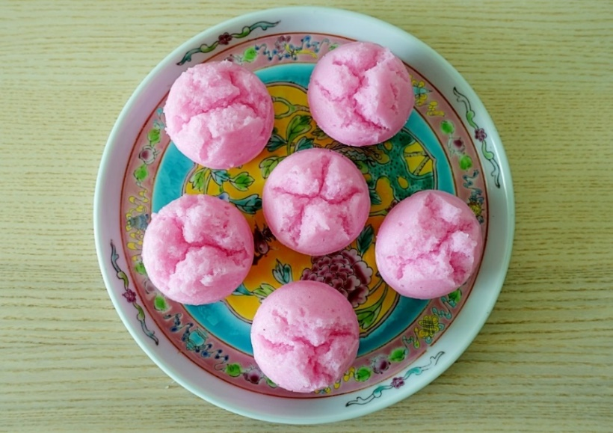

**Literature review**

**Baba Nyonya**

Peranakan Chinese call themselves Baba Nyonya, men are called Baba. Pue (2017) and Chia (2018) add that some Chinese-born Peranakans call themselves Peranakan without the word /Chinese/ to show that their ethnicity differs from their Chineseness. The women were called Nyonya because foreign married women are called Nyonya in Malay. It is a loanword from the old Portuguese word for lady *donha* (e.g., Macanese creole *nhonha* spoken in Macau, a Portuguese colony for 464 years) because Malays at that time tended to address all foreign women as Nyonya (Joo, 1996; Soeseno, 1981). In Penang Hokkien, it is pronounced *nō͘-niâ* (in Pe̍h-ōe-jī), said Tan (2016), and written with the phonetic loan characters 娘惹.

**Malay Language**

The Malay language, a member of the branch of the Austronesian language family, is spoken as a native language by more than 33 million people distributed over Peninsular Malaysia, Sumatra, Borneo, and the numerous smaller islands of the area. It is also widely used in Malaysia as the National language. The Malay pidgin called Bazaar Malay or Bahasa Mĕlayu Pasar (market Malay) was widely used as a lingua franca in the East Indian archipelago. It was the basis of the Dutch colonial language used in Indonesia. The Bazaar Malay used in Chinese merchant communities in Malaysia is called Baba Malay (Britannia, 2024).

**Baba Malay**

The language of Baba Nyonya is Baba Malay, a creole language similar to the Malay language, which includes many Hokkien words. Baba Malay is an endangered language (Lee, 2022), and its contemporary use is limited primarily to members of the older generation. Baba Malay is similar to Malay but combines some Chinese languages due to combining two different cultural languages. According to Bao (2015), Baba Malay was firmly entrenched in the Malay language, and they spoke the limited languages of their forefathers. Baba Nyonya from Melaka speaks Baba Malay, a creolised Malay with borrowed Hokkien and English words (Tan, 2010; Oh et al., 2019). Moreover, since its establishment in the 15th century, Melaka has been the base of the Sultanate of Melaka, the dominant regional culture. Baba Malay is the general term that refers to the Malay variety spoken by the Baba Nyonya in Melaka and Singapore. Baba Malay is a creolised language with many features of Bazaar Malay, the pidgin used as a lingua franca in the region (Aye, 2021). Baba Malay is a Malay dialect rather than a Creole or a mixed language (Thurgood, 1998). It seems not to have developed from a pidgin but was the first Chinese immigrants' family language as they intermarried with local women and adopted the community's language surrounding them. In fact, in an environment where the shifting group is small and has good access to the community's existing language, it is not just possible but likely that the group will not develop a creole. Instead, it will shift to the community's dominant language in contact (Thurgood, 1998), functioning as a contact language and partly to provide lexical items linked to Chinese culture that do not exist in Malay.

Baba Malay features a large number of words derived from Chinese (mostly Hokkien), which is the leading Chinese variety spoken in Melaka (Coluzzi et al., 2018; Lee, 2018), and several phonological and morphosyntactic features that may have in part derived from Hokkien, the substrate language (Shellabear, 1916; Pakir, 1986; Tan, 1988, 1993; Thurgood, 1998; Gwee, 2006; Lee, 2014, 2022). Baba Malay is the first language of Peranakan Chinese in Malaysia (Aye, 2021); the specific lexicon was mainly derived from Hokkien (e.g., ‘for’, first and second person singular subject pronouns, or table). Some of Baba Malay’s most striking features include typical endings /e/ [sampe] and /ay/ [sampay] for *sampai* (arrive). Other features, possibly derived from Hokkien, are morphosyntactic, such as the possessive form that precedes the noun—for example, *gua punya kerbó* instead of *kerbau aku* (my buffalo).

**Linguistic Integration**

Linguistic integration refers to the process by which individuals with a different language background can acquire the language skills necessary to participate fully in the host society. It involves not only the acquisition of the host language but also the development of intercultural communication skills and the adoption of the social norms and values of the host society. Linguistic integration is a complex process involving language acquisition, cultural adaptation, and social integration. It is essential to promote the inclusion of migrants in the host society (UNESCO, 2019).

In linguistics, integration refers to how different linguistic subsystems work together to form a coherent and efficient communication system. Khan (2020) adds that integration occurs at several levels and processes, such as phonological, morphological, orthographic, syntactic, semantic, and pragmatic (Table 2). A highly integrated language is one in which the different subsystems are tightly interconnected, whereas a less integrated language may exhibit more inconsistency in how its subsystems are used (Kettunen et al., 2021; Asadi et al., 2020; Zou et al., 2020).

**Table 2**

*Types of Integration Processes*

|  |  |
| --- | --- |
| Kinds of Integration Processes | Descriptions |
| Phonological Integration | The pronunciation of the source language is adapted into the phonological system of the recipient language. |
| Morphological Integration | The word of the source language is adapted into the morphological system of the recipient language. |
| Orthographic Integration | The set of a convention for writing a language of the source language is adapted into the orthographic system of the recipient language. |
| Syntactic Integration | The phrases and sentences of the source language are adapted into the syntactic system of the recipient language. |
| Semantics Integration | The literal meaning of phrases and sentences of the source language is adapted into the semantic system of the recipient language. |
| Pragmatics Integration | The meaning in the context of the discourse of the source language is adapted into the pragmatic system of the recipient language. |

**Morphological Integration**

Languages with higher levels of morphological complexity are inclined to be more highly integrated, suggesting that the different morphological subsystems in these languages are working together more efficiently (Kettunen et al., 2021). The highly integrated structures (e.g., subject-verb-object sentences) are processed more efficiently than less integrated structures (e.g., passive constructions), suggesting that integration plays a vital role in understanding and producing language (Asadi et al., 2020). In integration into multilingualism, speakers must navigate multiple linguistic subsystems to communicate effectively.

According to Zou et al. (2020), highly integrated languages are associated with more efficient language switching, suggesting that the degree of integration in a language can have essential implications for bilingual language processing (e.g., integration and language switching in bilingual Mandarin Chinese and English speakers). The concept of integration is essential in linguistics, as it sheds light on the complex interplay between different linguistic subsystems and how they contribute to the structure and function of language; this study emphasises integrating the Malay words in Nyonya cuisine in Melaka, Malaysia.

**Morphological Integration in the New Englishes**

It is essential to consider the systematic structure of morphology since this paper studies morphological integration. Morphology is the language’s grammar, including the development of words, structure, and the relation between words (Khan et al., 2020; Audring & Masini, 2008). Morphology integration means restructuring the morphology of the beneficiary language of the loanwords based on the morphology of the recipient language (Khan et al., 2020). Languages make up new words by combining the phonological or morphological structure of existing words, borrowing them from other languages, and integrating them into a new form (Matras & Adamou, 2020); *for instance, hee pio soup*, the word /soup/ is borrowed from English.

The phenomenon of morphological integration denotes the diverse manifestations of the English language that have emerged globally due to historical, social, and cultural influences (e.g., Singlish), according to Ningsih and Hamzah (2023). Bao (2003) labels four types of English, namely British English, American English, Singapore English, and Hong Kong English, which exhibit indications of morphological borrowings, such as integrating morphemes from other languages. The morphological systems of the specimens displayed varying degrees of integration. Singlish (Ningsih & Hamzah, 2023) and Hong Kong English exhibit greater morphological integration levels. In contrast, British and American English tend to rely more heavily on contextual cues or auxiliary verbs to convey similar meanings. Bao (2003) suggests these dissimilarities can be attributed to the impact of Chinese and other Asian languages (Fei, 2023), which significantly emphasise inflectional morphology and significantly impact Chinese students' English writing (Fei, 2023). These particular varieties frequently display distinct morphological characteristics indicative of their linguistic and cultural origins.

**Morphological Integration in Baba Malay**

According to Subramaniam and Muhammad (2010), the Malay language inspires aspects of grammar found in Baba Malay (Lee, 2014; 2022). The Malay language has profoundly influenced the Baba Malay vocabulary due to its ethnic assimilation. The most noticeable improvement process in Baba Malay is borrowing from Malay, Chinese, and other local languages. Borrowing has improved the Baba Malay lexicon and is pretentious in its syntax. As a result, the Baba Malay vocabulary undergoes the morphological integration of Malay words (Kawangit, 2015). According to Oh et al. (2019), Nyonya cuisines were inspired by integrating Malay, Chinese, and other provincial dialects (e.g., ***ayam*** *pongteh*; *ayam* is chicken and *pongteh or pongte* is braised meat with fermented bean and soy sauce).

A loanword is one of the most used morphological word-formation processes (Jdetawy & Hamzah, 2020). In addition, Campbell (2004) describes loanword as borrowed from the source language, which, in the first case, is not part of the vocabulary of the beneficiary language but is taken from the source language and developed into a part of the beneficiary language vocabulary (Schlüter & Wallenberg, 2021; Zuckermann, 2020). The language that gives its vocabulary to the other language is the donor language, and the language that receives new words is the beneficiary language. Morphological integration happens as the speaker of one language attempts to speak another using the first language's influence. The speaker then borrows the vocabulary from the first language, practised in daily activities, and blends it into the second language (Khan, 2020). This argument is vital to expanding the Baba Nyonya languages, which are comprised of Malay and Chinese words. This evident diversity makes it essential to consider the evolving integration of Malay words and morphological information in Nyonya cuisine.

However, other morphological word-formation processes that led to Baba Malay’s incorporation cannot be ignored because most language words have been coined through compounding. Lieber (2020) states that compounds have two or three bases, roots, or stems. In English, free bases are typically used to produce compounds (e.g., *bookstore*, *greenhouse*, *waterfall*). Compounding has played a significant role in enhancing the language of Nyonya. Nyonya cuisines mainly comprise Malay and Chinese languages (Chia, 2015; Nair & Nian, 2020). In this hybridisation process, a word of the Malay language is joined by a second word from Chinese, Tamil, Thai, or Indonesian languages. A single syllable of the local language is occasionally substituted by a single syllable in the various languages (Kachru, 1983). Nair and Nian (2020) highlight Baba Malay’s qualities in Nyonya cuisines as Malay and Chinese words, compounds, and borrowings form the vocabulary.

**Nyonya Cuisine**

Nyonya cuisine is among Southeast Asia’s best due to its distinctive fusion of Chinese and Malay culture, a legacy of marriages between Chinese settlers and native Malaysians in Melaka during the 16th and 17th centuries. Melaka became a commercial area in Malaysia and was a place where the Baba Nyonya were densely inhabited. The consistent migration of Chinese males to Melaka with their intermarriage with local women contributed to a unique Baba Nyonya community (Oh et al., 2019). The Baba Nyonya share a distinctive lifestyle that hybridises local and Chinese cultures. Nyonya cuisine is a delicious fusion of Malay and Chinese cooking with influences (Ng & Karim, 2016) from England, India, Indonesia, Thailand, and Portugal. Nyonya cuisine was unique in its identity (Tan, 1993) before it was even coined.

Nyonya has developed a unique cuisine, primarily spicy, using spices and aromatic leaves with Indo-Malay flavours (Oh et al., 2019), which emerged in Melaka (Ong, 2012); Portuguese and Indonesian mainly inspired Melaka Nyonya's cuisine (Tan, 2010; Yoshino, 2010). Baba Nyonya were early Chinese settlers who readily followed local traditions and customs, resulting in unique cultural assimilation in Melaka. Baba Nyonya from Melaka adopted Baba Malay with some Hokkien words; thus, Nyonya cuisines were termed after Malay and Hokkien (e.g., *ayam pongteh*). The Baba Nyonya culinary style combines Malay and Chinese elements, bringing a fusion of cultures, a true hallmark of multicultural diversity, from customs, dressing, and cooking to language (Kuake & Kuake, 2017). This study focuses on the Melaka-based Nyonya cuisine due to its authenticity, emergence, and originality in the region.

**Figure 2**

*Nyonya Cuisines* ***(****Source:**https://www.tripadvisor.com)*

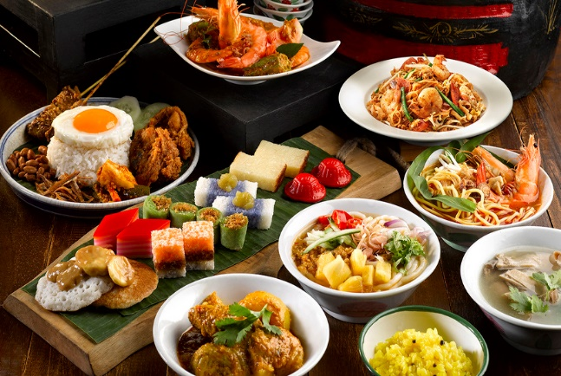

**Theoretical Framework: Kachru’s Deficit and Dominance**

Kachru (1983, 2005) suggests two theories for studying the origin of lexical borrowing in languages: deficit hypothesis and dominance. The deficit mentioned that borrowing implies linguistic differences in the language. The main reason for borrowing is to reduce the linguistic gap, especially in linguistic resources, that the speakers of a language borrow a word from another language, not to have a related word in their language. The prime objective of this kind of lexical borrowing is to fill the linguistic gap (Dashti & Dashti, 2017; Khan, 2020).

The dominance model suggests that when two cultures contact each other, culture learning and word-borrowing will lead from dominant to subordinate. Dashti and Dashti (2017) conclude that the speakers did not borrow words to fill the linguistic void but demonstrated the novelty of the individual language. Baba Nyonya used loanwords from Malay, Chinese, and other dialects to close semantics differences. Thus, the morphological incorporation of Malay words in Nyonya cuisines comes primarily under prevailing hypotheses (Wang et al., 2024) as the integration of new cultural symbols.

Fragkopoulou (2015) proposes a broad range of study opinions on the morphological integration of loanwords. The morphological integration of the words of the loanword is not absurd (Romaine, 2010). It is a steady and gradable process since it requires three degrees of integration: total integration, partial integration, and zero integration (Poplack & Sankoff, 1984), as mentioned in Khan (2020). The degree of morphological integration in the word is appropriate when the words are borrowed, which can be interpreted in the beneficiary language through morphological, phonological, and syntactic structures and code switches (Khan, 2020). The prospect of the recurrence of a word in the language of the beneficiary enhanced the chances of high integration of that word in the new language structure, which forms new loanwords that apply to the assumption of graduality (Poplack & Dion, 2012).

This study highlights the integration of Malay words in Nyonya cuisines, which expand on their diachronic and synchronic aspects (Saussure, 1916). In linguistic analysis, synchrony and diachrony are two opposing and corresponding points of view. A synchronic approach considers language without considering its past, whereas a diachronic approach is language’s creation and progression through history. Historical linguistics is generally a diachronic analysis (Anna et al., 2013; Nordquist, 2020). Saussure (1916) stresses the importance of the synchronic study of languages to understand their inner nature while never disregarding the importance of complementary diachrony. This theory has been used to explain the phenomenon of lexical borrowing in various languages, such as English, Bangla (Hoque et al., 2021), Arabic, and **Malay**.However, some scholars have criticised this theory for being ethnocentric and have proposed alternative or complementary perspectives, such as the creativity hypothesis, the identity hypothesis, and the hybridity hypothesis (Kachru, 2005). These hypotheses emphasise the role of the borrowers’ agency, creativity, and identity construction in lexical borrowing.

**Methodology**

The study goals were accomplished using a qualitative method. A qualitative study is observational, in which results are not in percentages (Sarantakos, 2013). Knowledge is practice or findings, not theory, and evidence can be in the form of pictures, artefacts, or videos in the empiric process (Punch, 1998). This approach stresses the openness and versatility of definition knowledge categories such as syntactic and semantic relationships. The researcher employed internet-based tools to conduct both traditional and contemporary ethnographic research. At the heart of ethnography is the concept that researchers gain insight into how individuals manifest their values, beliefs, and behaviours within a particular culture via extensive and ongoing engagement with research participants (Sharma & Chiranjit, 2016). The ethnographic report encompasses narratives, social norms, and cultural motifs derived from this prolonged gathering. Technography is a method that examines the social aspects of objects by conducting observations in modern ethnography (Kien, 2008). The study conducted by Silverman (2017) demonstrates that word analysis can provide a qualitative outcome. The research examined the Baba Malay language, specifically identifying knowledge categories and Nyonya cuisine.

A sample list of 17 chosen Nyonya cuisines named after the combination of Malay and Hokkien languages was selected using purposive samplingfrom various digital platforms (e.g., Facebook), particularly from Melaka because they are the origin of Baba Nyonya descendants. Samples gathered from secondary sources such as Nyonya cookbooks, magazines (e.g., *The Peranakan*), and Baba Nyonya books (e.g., *The Babas*) were analysed according to the Malay words and word-formation processes. This study used an analytical sampling process that relied on various qualitative testing designs, emphasising objective sampling to collect the requisite data from conclusions. Analytical approaches allow study designs to be more adaptive, allowing particular protocols to be implemented as required to achieve a goal.

The library review required a step-by-step process to collect information to prepare a complete report. Primary references are experiments done by other scholars; they identify, interpret, and/or assess the details found in primary sources. Researchers conducted library research to gather information regarding Baba Nyonya, Nyonya cuisine, and a suitable theoretical framework for the study. Researchers recorded the Nyonya cuisines according to their syntactic and semantic types (Appendix A), presented the Malay language integration in Nyonya cuisines, and analysed the word-formation and its processes.

The researcher conducted library research to gather information regarding Baba Nyonya, Nyonya cuisine, and a suitable theoretical framework for the study. This study used Lieber’s framework (2009) for loanwords/ borrowing and compounding. Loanwords were grouped into monomorphemic (phonologically using the categorisation of sound changes by Campbell, 2004) and polymorphemic loanwords (morphologically using the categorisation of word-formation) proposed by Bauer (2017) and Lieber (2020). This study highlights a morphological aspect of Baba Malay in Nyonya cuisine (Diagram 1). Regarding the degree of integration and reason for lexical borrowing, Kachru's framework for the dominance hypothesis (Diagram 2) was opted for the study. Then, observation was conducted on digital platforms to gather information regarding Nyonya cuisine's etymology, cooking methods, and ingredients (Figures 3 & Figure 4). The researcher recorded data according to their syntactic and semantic types (Appendix A), presented the Malay language integration in Nyonya cuisines, and analysed the word-formation and its processes. Flowchart 1 shows the procedure of analysis.

**Diagram 1**

*Loanwords in Baba Nyonya in Nyonya Cuisine*

**Diagram 2**

*Kachru’s Dominance Hypothesis*

**Figure 3**

*The Making of Cendol*



|  |  |
| --- | --- |
| **Figure 4**  *Nyonya Cendol* |  |

**Flowchart 1**

*Procedure of Analysis*

**Findings and discussion**

**Findings**

The list of 17 Nyonya cuisines from the Melaka region was collected and analysed using a morphological analysis process (refer to Appendix A) due to its authenticity and originality (Ong, 2012). Selected samples were further elaborated in the Discussion section, taking into account their combination of Malay + Hokkien or Hokkien + Malay compounds of Nyonya cuisine (this predominant criterion of Baba Malay in Melaka), types of syntactic (noun or adjective or verb), segmentation of the head and modifier of the source words to determine the left or right-headed compound. Although the researchers gathered many Nyonya cuisines, only selected ones were further analysed because this study focused on integrating Malay words in Melaka-based Nyonya cuisines. The researchers use the term *kueh*, following Baba Malay, to refer to the bite-size snack desserts, spelt as *kuih* or *kuih-muih* in standard Malay.

**Discussion**

It can be concluded that Nyonya cuisine is mostly named based on **compounding, borrowing, or loanwords**. This analysis recorded the hybridisation of Malay and Chinese words in Nyonya cuisine (refer to Appendix A). This section demonstrates the morphological integration of Malay words in Nyonya cuisine with examples. Tan (1979) formulates a framework for comparing Baba Malay and Standard Malay in terms of a framework of analysis. He maintains five main diversity patterns: ***loanwords, phonological, lexical, semantic, and syntactic differences***. Selected samples of Nyonya cuisine were discussed, and others were not because they fall under the same category or morphological processes; hence, only the specific ones were shown for readers to understand better.

**Figure 3**

*Ayam pongteh (Source:* [*https://peachesanddonuts.blogspot.com/ayam-pongteh-nyonya-chicken-stew.html*](https://peachesanddonuts.blogspot.com/ayam-pongteh-nyonya-chicken-stew.html)*)*

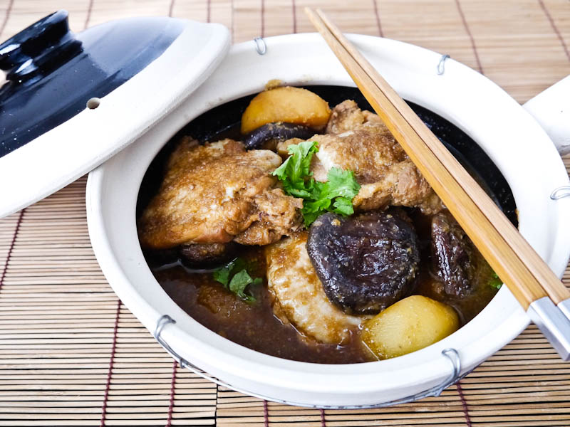

*Ayam pongteh* (Nyonya chicken stew)is a braised meat dish with potatoes, bamboo shoots and shitake mushrooms in fermented bean paste and soy sauce. The term /pong/ is mispronounced from the Hokkien word /hong/ for soy sauce stewing, while /teh/ means pig trotters. That is why *babi pongteh* is the first choice for cooking *pongteh*. Interestingly, the word /teh/ in Malay denotes meat tea or herbal soup. Thus, Baba Nyonya in Melaka eats *ayam pongteh* (Figure 3) during teatime with bread. Other than that, *ayam pongteh* is cooked tobeserved on special occasions (e.g., reunion dinner) or prayer dishes (e.g., ancestral prayer). The first base word, /ayam/ (noun), combines with the second base word, /pongteh/ (verb), to form an **open compound**. *Ayam pongteh* is a **left-headed compound** because *ayam* is the head, and *pongteh* acts as a modifier. The endocentric **headword** determines the word class of compound; *ayam pongteh* is an **open compound noun**.

**Figure 4**

*Ikan chuan-chuan (Source:* [*https://order.guanhoesoon.com/product/ikan-chuan-chuan/*](https://order.guanhoesoon.com/product/ikan-chuan-chuan/)*)*

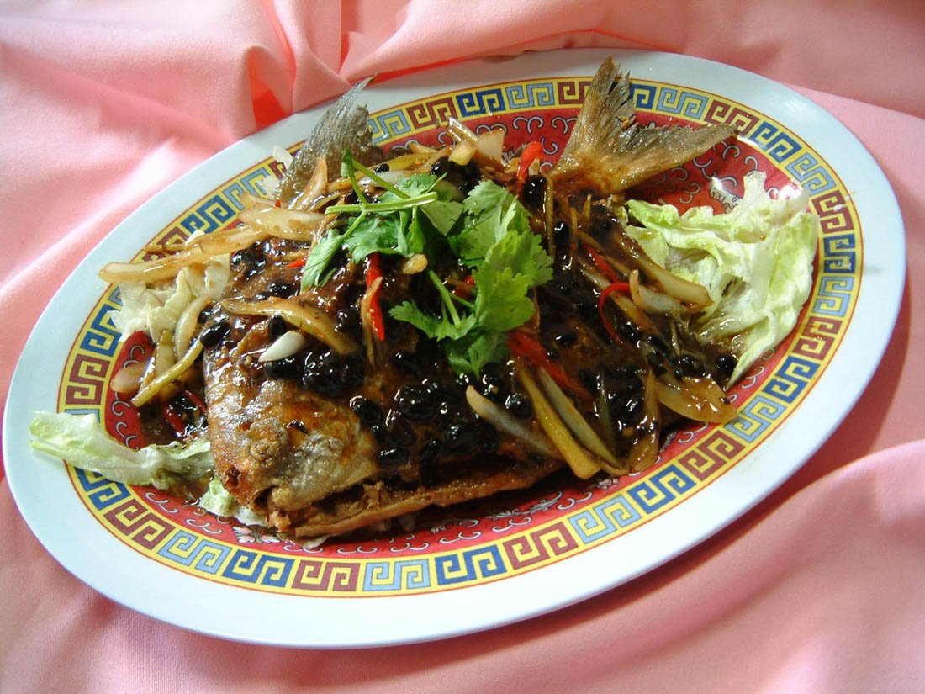

*Ikan chuan-chuan* (Figure 4) is a traditional Peranakan recipe that’s long been adopted by the Eurasian community. This is a forgotten old dish cooked for Chinese New Year. *Ikan chuan-chuan* is a fried fish dish in rich, earthy, piquant sauce (a combination of salted soy beans, tamarind (or vinegar), dark soy sauce). The cooking has two parts: fry the fish (less than 10 minutes), make the sauce (5 minutes), and then put it all together. The Nyonya cuisine combines the Malay word /ikan/ is fish (mostly pomfret is used), and the Hokkien word /chuan-chuan/, which means good fortune and longevity. The word /ikan/ (noun) combines with /chuan-chuan/ (adjective) to form an **open compound noun**. *Ikan chuan-chuan* is a **left-headed compound** because *ikan* is the headword, and *chuan-chuan* acts as a modifier. The word formations involved in this dish are compounding and reduplication (chuan-chuan).

**Nyonya Kueh: Pulot tekan/ pulot tartair/ pulut tai tai**

**Figure 5**

*Pulot tekan (source:* [*https://mylovelyrecipes.com/recipes/nyonya-cuisine/pulut-tai-tai/*](https://mylovelyrecipes.com/recipes/nyonya-cuisine/pulut-tai-tai/)*)*

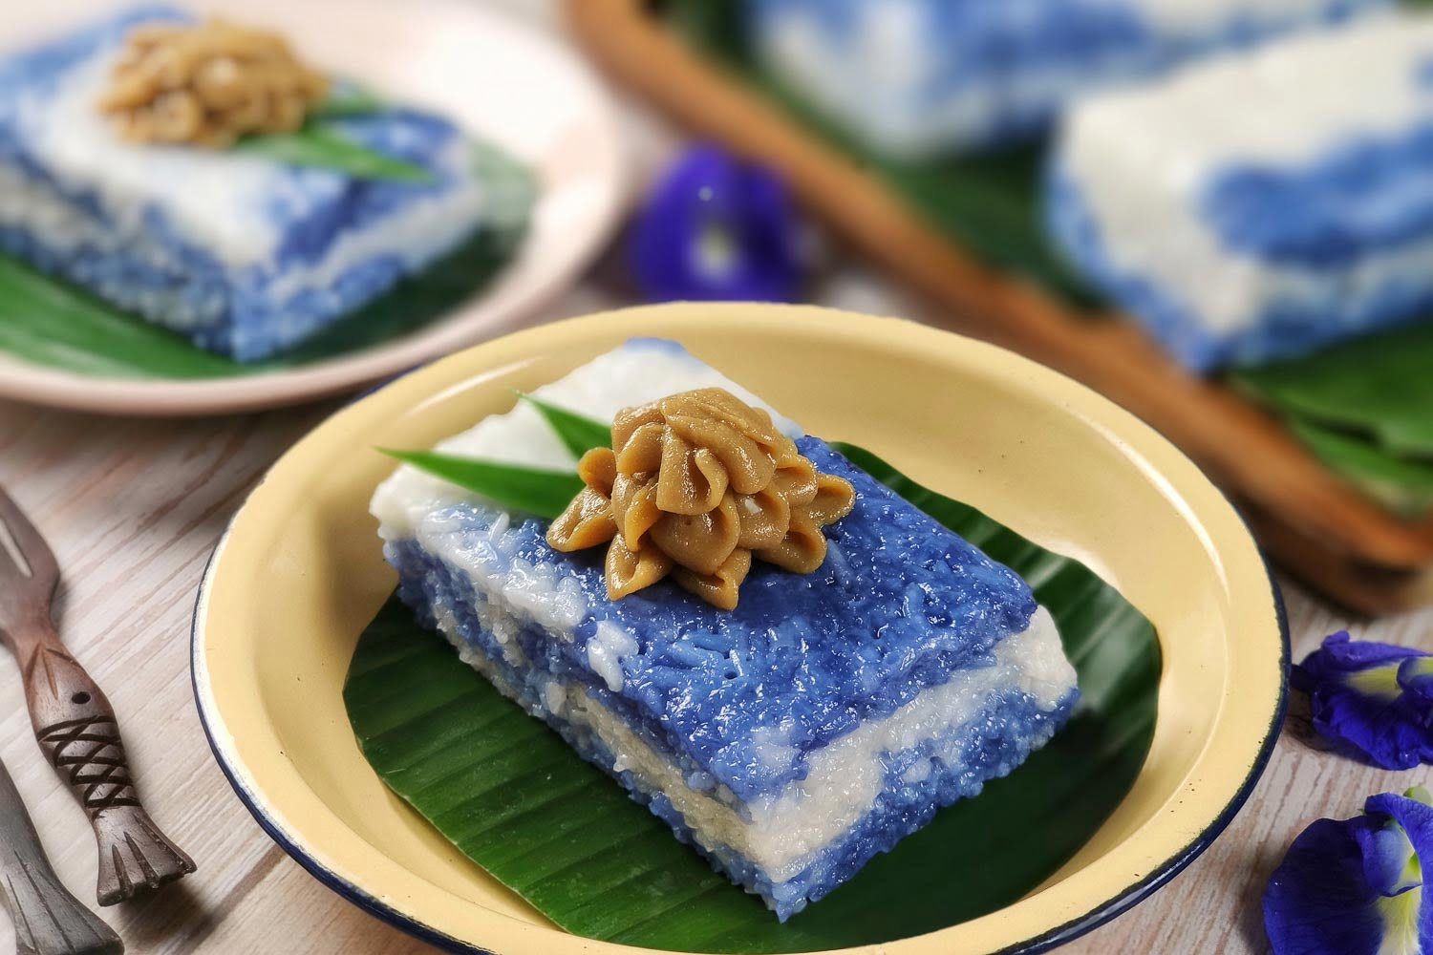

*Pulot tekan or pulut tai tai* (Figure 5) is a blue glutinous rice cake. The base words /*pulut*/(Malay) and /*tai tai*/ (Chinese) form an open compound. It is a traditional Nyonya kuih that wealthy Nyonya ate during teatime. *Pulut tai tai* is an elegant dessert served among Nyonya where the word /*tai tai*/ denotes a wealthy woman and was served to rich men’s wives back then. It is a Nyonya kueh made of steamed glutinous rice in coconut milk and served with coconut milk spread (kaya). Another interesting fact is that the *pulot*, which is eaten with kaya, is called *pulot tekan*, while it is eaten with *santan* (coconut milk, salty and sweet), called *pulot tartair*. *Pulot tekan* (pressed glutinous rice) is named after the cooking method of dessert; /tekan/ (in Malay) means pressing. The first base word /pulot/ (noun), is combined with the second one /tekan/ (verb), to form an **open compound noun.** The word /*pulot*/ is the headword, and /tekan/ or /*tai tai*/ is the modifier, a **left-headed endocentric compound**.

**Nyonya Kueh: Nyonya chang or kueh chang**

**Figure 6**

*Nyonya chang* (source: <https://www.rebeccasaw.com/nyonya-chang-nyonya-dumplings-in-melaka/>)

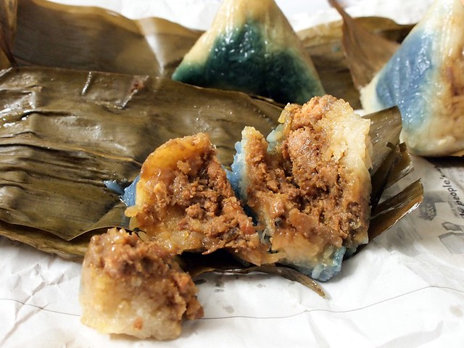

In Baba Malay*, kueh chang or Nyonya chang* (Figure 6)is the famous variety of /*bak chang*/, which means meat dumplings in Hokkien. It is also known as *zongzi,* and the Hokkien word /*chang*/ means dumpling (zong, 粽). It is a sticky rice dumpling eaten during the Dragon Boat Festival (Duanwu Festival) in honour of Qu Yuan, a poet and a court official in the ancient state of Chu Who. There are six types of bak chang (Figure 7): Hokkien bak chang, Cantonese bak chang, Teochew bak chang, *Nyonya bak chang*, Hainanese bak chang and Kee chang. The *Nyonya chang* is a famous dumpling in Melaka with a natural blue-dyed colour from the butterfly pea flower (*bunga telang* in Malay). *Nyonya chang* is cooked with savoury stuffing and a more balanced blend of sweet and salty: minced pork, candied winter melon, mushrooms, and spices. The first base word, /Nyonya/ (noun), is the modifier combined with the second one, /*chang*/ (noun), which is the headword that forms a **right-headed endocentric compound**.

**Figure 7**

*Types of Bak Chang (Source:* [*https://www.reddit.com/r/malaysia/14hofdl/types_of_bak_chang/?rdt=58564*](https://www.reddit.com/r/malaysia/14hofdl/types_of_bak_chang/?rdt=58564)*)*

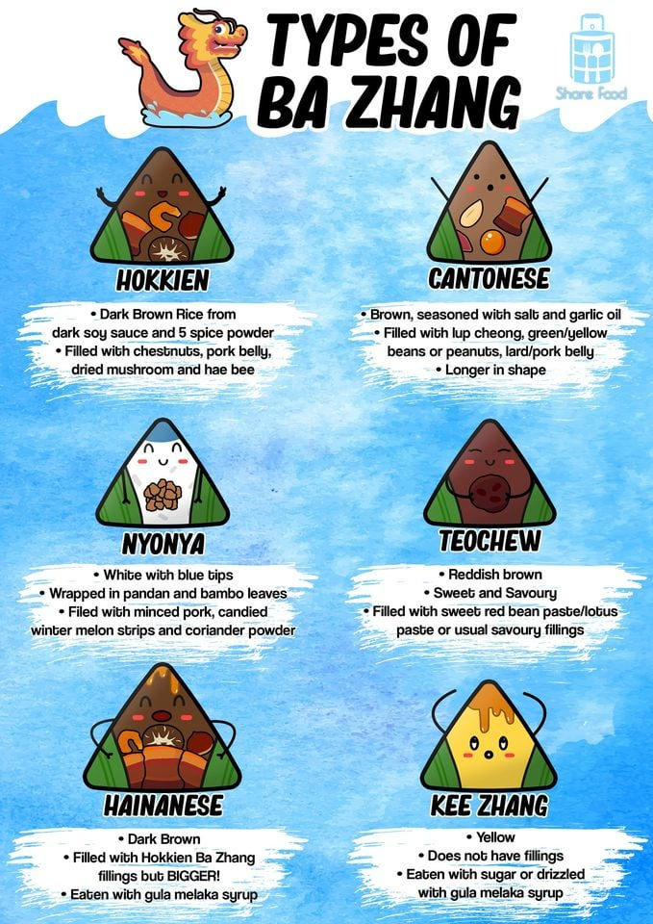

**Nyonya Kueh: Ang ku kueh or kueh ku merah**

**Figure 8**

*Ang ku kueh (source:* [*https://www.malaymail.com/the-art-of-making-nyonya-kuih/643987*](https://www.malaymail.com/the-art-of-making-nyonya-kuih/643987)*)*

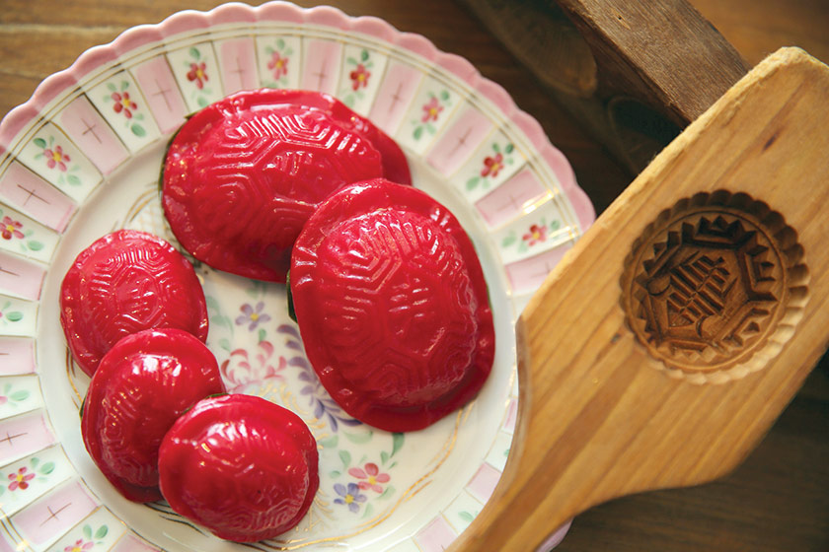

The *angku kueh,* or *kueh ku* *merah* (Figure 8), symbolises the tortoise, which means longevity. *Angku kueh* means red tortoise cake; mung bean filling is a popular Hokkien dessert eaten on special occasions. The Hokkien word /koe/ refers to cake or dumpling, which entered the Malay vocabulary (e.g., *kueh* in Baba Malay and *kuih* in Standard Malay) a few centuries back (Figure 9-10). The Baba Nyonya refer to Hokkien pastry, which conforms to the Malay grammar, with the noun before the adjective rather than the adjective preceding the noun in Chinese words. Over time, *ang ku kueh* became the *kueh ku merah* (in Baba Malay). The word formation undertakes a double level of compounding (Table 4): /ang/ is red, and /ku/ is tortoise. At the first level, the word /ang/ is combined with /ku/ to become /angku/. The word /angku/ combines with /kueh/ in the second level of compounding. The adjective modifies the noun, describes its referent, and changes the semantic role of the noun. *Ang ku kueh* is a **right-headed endocentric compound** because *kueh* is the head, *ang ku* is the modifier, and *kueh ku merah* is a **left-headed compound**. These patterns present that all headed compounds are endocentric (Chart 1).

**Table 4**

*Levels of Word-formation*

|  |  |  |  |  |  |  |
| --- | --- | --- | --- | --- | --- | --- |
| First level modification | | Second level modification | | Final Word | Syntactic Type | Semantic Type |
| Compounding | | **Compounding** | | *ang ku kueh* | compound noun | endocentric compound (modifier + head) |
| ang (red) | ku (tortoise) | angku | kueh |
| adjective | noun | adjective | noun |
| modifier | head |

**Chart 1**

*The Headedness and Endocentric Compounds*

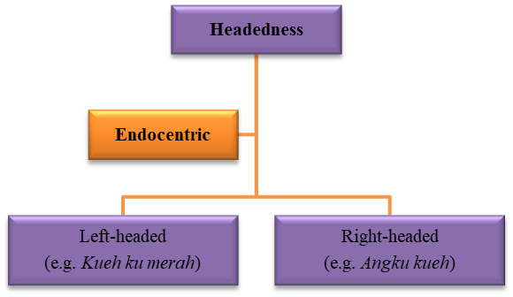

**Figure 9**

The Etymology of Koe

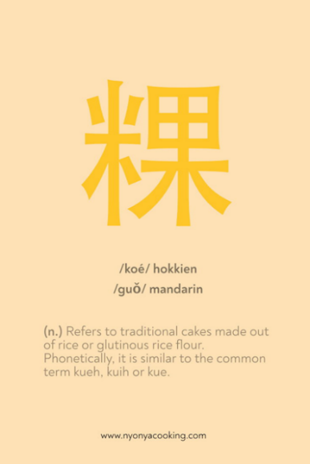

**Figure 10**

*Different Spelling of Koe*

**Conclusion**

Nyonya cuisine is a heritage food that reflects Malaysia's cultural diversity and fusion. It is a product of the Peranakan community, which consists of descendants of Chinese immigrants who married local Malays in the Malay Archipelago. Nyonya cuisine combines Chinese ingredients and cooking techniques with Malay spices and flavours, creating a unique and distinctive culinary tradition. This study investigated the Malay word integration and its word-formation processes in Nyonya cuisines and achieved the study's objectives. This study concluded that Malay words play a vital role in Baba Malay, which can be witnessed in Nyonya cuisines. Malay word integration in Nyonya cuisines can be classified into **Malay + Chinese** (e.g., *itek tim*) and **Chinese + Malay** (e.g., *angku kueh*) with the help of Kachru’s (1983, 2005) theoretical framework to explore loanwords in Baba Malay.

Baba and Nyonya people use Malay words to name Nyonya cuisine to express a notion or describe an object in their local language. Lexical demands drive single-word borrowing, mostly in the form of compound nouns (e.g., *tekan*, *bubor*). Cultural borrowings (new to the recipient language culture) and core borrowings (lexical items with viable equivalents in the recipient language) account for all established borrowings. According to Myers-Scotton (1992, 2006), the giving language's core borrowed items are more symbolic than the recipient languages. The donor language's lingua franca encourages using Baba Malay lexical elements without modifying their phonology. Thus, educated bilingual speakers may perform elite closure by deliberately pronouncing borrowed words as closely as possible (e.g., koe is pronounced kueh). Kachru (2005) supports this claim with two hypotheses: deficit and dominance. According to the deficit hypothesis, the receiver language borrows from another language to cover lexical gaps. Thus, borrowing is mainly done to improve the receiving language. However, the dominance hypothesis states that lexical items are not necessarily borrowed to cover the receiving language’s needs. The symbolic prestige of a lingua franca influenced Baba Malay to borrow Malay words. The dominance theory accepts that one language enjoys a higher prestige than the other, making users less likely to shift to the more dominant one.

This study reconfirmed that most Nyonya cuisines are **compound words** (Nair & Nian, 2020). The compounds are adjectives, nouns, and verbs. Most Nyonya cuisines are compound nouns, endocentric compounds, and right-headed compounds. The semantic classifications reveal that the positions of right-headed (modifier + **head**) and left-headed (**head** + modifier) are compounds. The right-headed compound, as seen in *chai kueh* (vegetable dumpling), *chai* is the vegetables (modifier), and *kueh* is the dumpling (head). This study reported that all the headed compounds are endocentric. A compound can be categorised as left-headed and right-headed based on the head’s placement without changing the word’s meaning. Furthermore, the headed base word determines the syntactic of the words (e.g., ayam pongteh is a compound noun) because the head, ayam, is a noun. *Angku kueh* (Baba Malay) or *kueh ku merah* (Malay), the head of the word, is changed to determine the headedness without changing the word’s meaning.

Nowadays, tourists are more aware of the importance of nourishment and culinary experience when selecting a destination. Malaysia is known for its diversity, contributing to its heritage history and the expansion of the food tourism industry. Specifically, Melaka serves authentic cuisines from many cultures that have originated from many backgrounds, which are still served now and have become a part of the food heritage in Melaka. The culture, such as Baba Nyonya cuisine, differentiates the heritage food in Melaka. Baba Nyonya cuisine combines Malay and Chinese cooking, eventually influencing the dish's naming (e.g., pulot tekan). It is well-known to be flavourful and tasty.

Nyonya cuisine contributed to language research and cultural studies in several ways. It reveals the linguistic influences and borrowings between Chinese, Malay, and other languages, such as Dutch, English, Portuguese and Tamil. Many Nyonya dishes have names derived from or influenced by these languages, such as *kari*, *kueh*, and *sambal*. It also illustrates the cultural adaptation and hybridisation of the Peranakan community as they assimilate and integrate with the local Malay society. Nyonya cuisine reflects the Peranakan identity, which is neither purely Chinese nor Malay but a blend of both. Apart from that, it demonstrates Malaysia's cultural diversity and harmony, as Nyonya cuisine is enjoyed and appreciated by people of different ethnicities, religions, and backgrounds. Nyonya cuisine symbolises unity and tolerance, as it celebrates the richness and variety of Malaysian culture.

Food is a unity tool in Malaysia, as it brings people together and fosters social interactions and bonds. Food is also a way of expressing and sharing one's culture and identity and learning and respecting others' cultures and identities. Nyonya cuisine is one of the many examples of how food can promote unity and diversity in Malaysia. Nyonya food in Melaka is a heritage cuisine that exemplifies the beauty of cultural diversity and fusion, and its linguistic and cultural aspects can provide valuable insights for researchers and scholars. This study developed an idea for researchers to study further Malay word integration in Nyonya cuisines regarding morphological and phonological prospects in broad regions, including Singapore, Indonesia, and Thailand.

**Acknowledgement**

I would like to extend my heartfelt appreciation to Multimedia University (MMU) for providing us with the opportunity to participate in this competition. I am profoundly grateful to Dr Ong Shyi Nian, a retired Senior Lecturer from the University of Malaya, for his invaluable support and guidance in writing this academic paper and participating in this competition. I would also like to express my deepest gratitude to my supervisor, Dr. Nurul Huda binti Hamzah, for her unwavering moral support. Lastly, I am incredibly thankful to my family, whose constant support throughout my academic journey has inspired my research.

**References**

Anna, G. R., Caterina, M., Piera, M. (2013). *Synchrony and Diachrony: A Dynamic Interface.* Philadelphia, Pennsylvania: John Benjamins. North America. 17–18.

Ansaldo, U., Lim., L, Mufwene. S. S. (2007). *The Sociolinguistic History of The Peranakans: What It Tells Us About ‘Creolisation’.* John Benjamins Publishing Company; pp. 203–26.

Asadi, A., Rossi, S., & Swaab, T. Y. (2020). *Integration in the processing of syntactic structures: An fMRI study*. Journal of Memory and Language.

Audring, J. & Masini, F. (2008). *The Oxford Handbook of Morphological Theory.* Oxford: Oxford University Press.

Aronoff, M. & Fudeman, K. (2023). *What is morphology?* (3rd ed.). *John Wiley & Sons Ltd*.

Aye, K. K. (2021). *The Nature of Sinitic Lexicon in Bazaar Malay and Baba Malay in Singapore.* Sinophone Southeast Asia.

Azmi, N. & Mohamad, D. & Mohamed, B. (2018). *Beaded shoes: the culture of Baba Nyonya.* SHS Web of Conferences. 45. 02003. 10.1051/shsconf/20184502003.

Bao, Z. (2003). *Morphological typology and Chinese learners of English.* World Englishes, 22(2), 145–160.

Bao, Z. (2015). *The Making of Vernacular Singapore English: System, Transfer, and Filter.* Cambridge University Press.

Bauer, L. (2017). *Compounds and Compounding.* Cambridge: Cambridge University Press.

Britannica, T. Editors of Encyclopaedia (2024). *Malay language.* Encyclopedia Britannica. <https://www.britannica.com/topic/Malay-language>.

Campbell, L. (2004). *Historical Linguistics: An Introduction*. Edinburgh: Edinburgh University Press.

Cheah, H. (2018). *Baba Nyonya culture: A brief introduction.* Travel Triangle.<https://traveltriangle.com/blog/baba-nyonya-culture/>

Chia., F. (2015). *The Babas.* Published by Landmark Books.

Chia, J. (2018). *I am Peranakan, not Chinese.* Channel News Asia.

Coluzzi, P., Riget, P. N., & Kitade, R. (2018). *Is the Baba Nyonya a doomed minority?* *A preliminary study on the vitality of Baba Malay in Melaka (Malaysia).* Grazer Linguistische Studien, 89, 111-139.

Dashti, F. & Dashti, A. A. (2017). *Morphological Adaptation of English Loanwords in Twitter: Educational Implications.* International Journal of Higher Education, *6*(1), 1–18.

Fragkopoulou, K. (2015). *On Gradualness of Morphological Integration of Loanwords in Heptanesian.* Geek Linguistics, *12*(1), 1–34.

Fei, Y. (2023). *The Differences in Thinking Patterns Between English and Chinese in Chinese Students’ English Writing*. Proceedings of the 2nd International Conference on Education, Language and Art (ICELA 2022).

Fromkin, V. & Rodman, R. (1998). *An Introduction to Language.* Harcourt Brace College Publishers. Language and Languages.

Gwee, W. T. H. (1998). *Mas Sepuloh: Baba Conversational Gems*. Singapore: Armour Publishing.

Gwee, W. T. H. (2006). *Baba Malay Dictionary: The First Comprehensive Compendium of Straits Chinese Terms and Expressions.* Tuttle Publishing.

Hoo, R. (2018). *Chronicling Nyonya Cuisine.* Penang Monthly. [www.penangmonthly.com](http://www.penangmonthly.com).

Hoque, M., & Ali, M. M., & Puteh-Behak, F., & Baharun, H. (2021). *Lexical borrowings from the English language into Bangla short stories*. 17. 158-172. 10.52462/jlls.9.

Hussin, N. (2007). *Trade and Society in the Straits of Melaka: Dutch Melaka and English Penang.* NUS Press.

Hwa, W. E. (2010). *Cooking for the President: Reflections & Recipes of Mrs. Wee Kim Wee.* Publisher: Wee Eng Hwa. ISBN: 9810836775.

Jdetawy, L., & Hamzah, M. H. (2020). *Loanwords in the Taxonomy of Borrowing: A Sociolinguistic Analysis*. 20. 98-135. Language in India www.languageinindia.com.

Kachru, B. B. (1983). *The Indianisation of English: The English language in India.* New Delhi: Oxford University Press.

Kachru, B. B. (1994). *Englishization and Contact Linguistics.* World Englishes, *13*(2), 135–154.

Kachru, B. B. (2005). *Asian Englishes Beyond the Canon.* Hong Kong University Press.

Kawangit, R. M. (2015). *Assimilation of Baba and Nyonya in Malaysia.* International Journal of Social Science Studies, *3*(2), 11–20.

Kemmer, S. (2003). *Borrowed words. Words in English.* Rice University.

Kettunen, K., Vihman, M., Palancar, E., & Chumakina, M. (2021). *Morphological complexity and integration in cross-linguistic comparison*. Journal of Language Evolution, 6(1), 1-25.

Khan, T. A. (2020). *Morphological Integration of Urdu Loan Words in Pakistani English*. English Language Teaching; Volume. 13. Canadian Centre of Science and Education.

Kien, G. (2008). *Technography = Technology + Ethnography: An Introduction*. Qualitative Inquiry - QUAL INQ. 14. 1101–1109. 10.1177/1077800408318433.

Kuake, J.B. & Kuake, S.B. (2017). *Culture Indulgence: Communicating in the Language of Nyonya Cuisine*. International Journal of Culture and History, *3*(3), 190–197.

Lee, N. H. (2014). *A Grammar of Baba Malay with Sociophonetic Considerations.* Manoa: University of Hawaii.

Lee, N. H. (2018). *Baba Malay: Diverging trends in two ecologies*. Journal of Pidgin and Creole Languages. 33. 136–173. 10.1075/jpcl.00004.lee.

Lee, N. H. (2022). *A grammar of modern Baba Malay.* Berlin, Boston: De Gruyter Mouton.

Lieber, R. (2020). *The Nature of Compounding.* Language and Linguistics Compass.

Lim, B. S. (2009). *Distinctly Peranakan Hokkien.* The Peranakan Association Singapore; Raffles City (Singapore): p. 14.

Liu, G. (2019). *The development of the Peranakan identity in Singapore.* Springer.

Matras, Y., & Adamou, E. (2020). *Borrowing*. The Routledge Handbook of Language Contact, Routledge, pp.237-251.

Nair, K. D. & Nian, O. S. (2020). *Compound Words of Malay and Chinese Languages in Nyonya Recipes.* Platform - A Journal of Management & Humanities.

Nasution, S. (1989). *Kamus Umum Lengkap: Inggris-Indonesia Indonesia-Inggris*. University of California.

Ng, C. Y, & Karim, S. A. (2016). *Historical and contemporary perspectives of the Nyonya food culture in Malaysia.* Journal Ethnic Foods. *3*(2):93–106.

Ningsih, N. S., & Rahman, F. (2023). *Exploring the Unique Morphological and Syntactic Features of Singlish (Singapore English).* Journal of English in Academic and Professional Communication JEAPCO, 9(2).

Nordquist, R. (2020). *An Introduction to Historical Linguistics: Definition and Examples.* https://www.thoughtco.com/historical-linguistics-term-1690927.

Oh, Y., Razak, N. F. A. H. A., Wee, D. H. T., Ching, E. L., Rahman, Z. (2019). *The Development of Nyonya Cuisine in The Malay Archipelago: Penang and Malacca Nyonya Cuisine.* Journal of Ethnic Foods. Volume. 6.

Ong, J. T. (2012). *The Pearl and The Lion.* The Peranakan, Volume. 2.

Online Oxford Dictionary (2022). <https://dictionary.cambridge.org/dictionary/english/oxford>

Pakir, A. (1986). *A Linguistic Investigation of Babas Malay.* Hawaii: University of Hawaii.

Poplack, S. & Sankoff, D. (1984). *Borrowing the Synchrony of Integration*. Linguistics, 22, 99–135.

Poplack, S. & Dion, N. (2012). *Myths and Facts about Loanword Development.* Language Variation and Change, 24(3), 279–315.

Punch, K. F. (1998). *Qualitative Research: Overview, Design, and Grounded Theory. Introduction to Social Research: Quantitative and Qualitative Approaches.* London: Sage.

Romaine, S. (2010). *Language Contact in the United States.* Cambridge: Cambridge University Press.

Sarantakos, S. (2013). *Social Research.* Fourth Edition, Palgrave Mac-Millan, New York.

Saussure, F. (1916). *Course in General Linguistics.* London: Duckworth.

Sharma, H., & Chiranjit, S. (2019). *Ethnography Research: An Overview*. International Journal of Advance and Innovative Research.

Shellabear, W. G. (1913). *Baba Malay: An Introduction to the Language of the Straits Born Chinese.* Journal of the Straits Branch of the Royal Asiatic Society. 65: 49-63.

Seah, C. L., & Durai, J. T. (2021). *The Peranakan Chinese in the Malay world: A cultural study.* Routledge.

Schlüter, J., & Wallenberg, J. (2021). *Borrowing and the Role of Language Contact in the Development of English Vocabulary*. Journal Language and Linguistics Compass.

Silverman, D. (2017). *Doing qualitative research*. London; Thousand Oaks, California: SAGE Publications Ltd.

Subramaniam, V., & Mohammad, W. M. R. W. (2010). *Elements of Language and Assimilation of Malay Language in Baba and Nyonya Community in Malaysia.* Asian Social Science, *6*(6).

Tan, C. B. (1979). *Baba and Nyonya: A Study of the Ethnic Identity of the Chinese Peranakan in Malacca.* Ithaca: Cornell University.

Tan, C. B. (1988). *Structure and Change: Cultural Identity of the Baba of Melaka*. Land-en Volkenkunde. 144, 297–314.

Tan, C. B. (1993). *Chinese Peranakan Heritage in Malaysia and Singapore.* Selangor: Penerbitan Fajar Sdn. Bhd.

Tan, C. B. (2010). *Peranakan Chinese in Northeast Kelantan with Special Reference to Chinese Religion*. Journal of the Malaysian Branch of the Royal Asiatic Society.

Tan, F. (2009). *Recipes from The Nyonya Kitchen by Florence Tan.* E-book.

Tan, K. S. (2016). *Peranakan Malay language: An overview of its grammar and sociolinguistic features.* Journal of Nusantara Studies, *1*(2), 33–45.

Tan, P. Y. (2020). *Peranakan Chinese heritage in Southeast Asia.* Singapore: World Scientific Publishing.

Thurgood, E. (1998). *A Description of Nineteenth-Century Baba Malay: A Malay Variety Influenced by Language Shift.* Department of Linguistics, University of Hawaii, Hawaii.

UNESCO. (2019). UNESCO’s commitment to the global compact on refugees.

Wang, X., Zainudin, S. S. S., & Yaakup, H. S. (2024). *Nyonya Culture Expression in Malaysian Chinese Media Based on Facebook*. Studies in Media and Communication. Redfame Publishing.

Yoshino, K. (2010). *Malaysian Cuisine: A Case of Neglected Culinary Globalization.* Tokyo (Japan): Sophia University Institute of Comparative Culture.

Zou, L., Abutalebi, J., & Thierry, G. (2020). *The effect of language integration on bilingual language switching: An ERP study.* Bilingualism: Language and Cognition, 23(2), 261-276.

Zuckermann, G. (2020). *Language Contact and Lexical Enrichment in Israeli Hebrew.* Oxford University Press.

**Appendix A:**

|  |  |  |  |  |  |  |  |
| --- | --- | --- | --- | --- | --- | --- | --- |
| Morphological Integration of Malay and Hokkien Words | | | | | | | |
| Nyonya Cuisine | **Meanings** | | | | **Word-formation** | **Syntactic** | **Semantic** |
| ***Malay*** | | ***Hokkien*** | |
| *ayam buah keluak* | ayam (chicken) – noun | | buah keluak (black nut) – noun | | open compound | compound noun | left-headed endocentric compound |
| *ayam lor* | lor (thick gravy) – adjective | |
| *ayam pongteh* | pongteh (stew) – verb | |
| *ayam sioh* | sioh (roasted) – verb | |
| *bubor cha-cha* | bubor (porridge) – noun | | cha-cha (dance) – noun | |
| *ikan chuan-chuan* | ikan (fish) – noun | | chuan-chuan (good fortune and longevity) – adjective | |
| *kacang panjang chai po* | kacang panjang (long beans) – noun | | chai po (preserved radish) – noun | |
| *Nyonya chang* | Nyonya (married woman) – noun | | chang (dumpling) – noun | | right-headed endocentric compound |
| Nyonya Cuisine | **Meanings** | | | | **Word-formation** | **Syntactic** | **Semantic** |
| ***Hokkien*** | | ***Hokkien*** | |
|  |  | |  | |
| *kueh ee* | kueh (snack/dessert) – noun | | ee (round) – adjective | | open compound | compound noun | left-headed endocentric compound |
| *kueh ko swee* | ko swee (beautiful) – adjective | |
| *ang ku kueh* | angku (red tortoise) – adjective + noun | | kueh (dessert) – noun | | open compound | compound noun | right-headed endocentric  compound |
| *huat kueh* | huat (prosperity) – adjective | |
| Nyonya Cuisine | **Meanings** | | | | **Word-formation** | **Syntactic** | **Semantic** |
| ***Malay*** | | ***Malay*** | |
| *buah Melaka @ onde-onde* | buah (fruit) –  noun | | Melaka (Malacca) – noun | | open compound | compound noun | exocentric compound |
| *pulot tekan* | pulut (glutinous rice) – noun | | tekan (press) – verb | | left-headed endocentric compound |
| *udang masak lemak nenas* | udang (prawn) – noun | masak (cook) – verb | lemak (fat) – noun | nenas (pineapple) - noun | open compound | compound noun | left-headed endocentric compound |
| Nyonya Cuisine | **Meanings** | | | | **Word-formation** | **Syntactic** | **Semantic** |
| **Hokkien** | | **Baba Malay** | |
| *bakwan kepiting* | bakwan (pork meat) - noun | | kepiting (crab) - noun | | open compound | compound noun | exocentric  compound |
| *kueh tair* | kueh (snack/dessert) – noun | | nanair/ tair (pineapple tart) – noun | | open compound | compound noun | left-headed endocentric  compound |

Note:

The yellow coloured-column is the headwords which determine the endocentric compound (right-headed or left-headed endocentric compound)