Journal of Informatics and
Web Engineering
Vol. 5 No. 1 (February 2026) eISSN: 2821-370X

Comparative Analysis of the Performance of CSS Animation Methods (Transition and Animation) under High DOM Load
Dmitrii Zakharov^{1*}, Ekaterina Mironenko²
¹Independent Researcher, Slovenia
²Independent Researcher, Cyprus
*corresponding author: (forsocials.mail@gmail.com; ORCiD: 0009-0000-4574-1425)

Abstract – This study provides a comparative analysis of the performances of Cascading Style Sheets (CSS) animations and transitions based on modern web interfaces, highlighting the impact of varying levels of complexity. The comparative analysis includes scenarios of animating between 50 and 10,000 elements and assessing three key metrics: frames per second (FPS), delta, and JavaScript heap memory consumption. All research was conducted using modern browsers and devices to ensure reliable and interpretable results. Low-load testing (50 – 2,500 elements) demonstrated consistent metric results for both approaches. At the same time, moderate-load testing (2,500 – 5,000 elements) demonstrated that CSS animations can deliver more FPS than transitions, but with the same memory consumption. Finally, high-load testing (7,500 – 10,000 elements) demonstrated that animations can consume up to 14% more memory than transitions, and the stability of the FPS is lower. The number of experiments and collected metric data were processed using median values to avoid artifacts. Null hypothesis testing was applied to each metric across different test scenarios to determine whether the observed differences were statistically significant or were due to random variation. Utilizing the significance threshold of α = 0.05, we calculated the FPS, delta, and memory consumption for all executed tests. The results of all tests showed that memory consumption was the metric most affected by the different levels of load testing. When metric weights were assigned based on priority, memory consumption was higher in the animation approach. However, at the same time, the FPS delta recorded that animations were slightly more effective (0.13%). When equal weights are applied to the FPS, delta, and Memory Consumption, the transitions demonstrate a slight advantage (0.03%). These findings indicate trade-offs between smooth rendering and resource efficiency, particularly for high-load interfaces. CSS animations and transitions are viable options for scalable, responsive UI designs.
Keywords - Cascading Style Sheets, Animations, Performance Testing, Web Engineering, Document Object Model, Frontend

Received: 09 May 2025; Accepted: 11 August 2025; Published: 16 February 2026
This is an open-access article under the CC BY-NC-ND 4.0 license.

- INTRODUCTION

Every day, over 250,000 new websites are registered worldwide, translating to approximately 175 new sites every minute [1]. In this competitive landscape, modern web applications must not only be functional but also highly optimized for user interface performance.

1.1 Relevance of Interface Optimization
Best practices in front-end development typically include animations or transitions for content management, page loading, routing, and other interactions. Visual effects such as smooth transitions and animations play a critical role in improving user experience (UX) and keeping users engaged [2]. However, having too many animated elements running simultaneously can reduce interface performance, particularly on devices with limited resources, because users expect websites to respond and load within 1–2 s, and performance becomes a vital factor in the competitiveness of web applications [3]. Typical modern web applications include dashboards, real-time visualizations, alerts, menus, core content, and other interactive interface elements. These elements are often animated simultaneously or consistently during rendering, which adds visual complexity to modern web applications.

1.2 Problem Statement
The domain-accepted recommendations and best practices for using CSS animations and transitions are descriptive and qualitative, making it difficult to select the best approach for developing high-load interfaces. Furthermore, this area remains open to research, as there are few benchmarks or studies focused on optimization, but those that exist often concentrate on small-scale examples or ideal conditions. Simultaneously, more websites are being created every day, and this study aims to highlight this issue.

1.3 Research Objective
The goal of this research is to evaluate the quantitative performance of CSS animations and transitions using experimental data, while developing informed recommendations for their use in highly visually demanding interfaces. All data metrics collected should be validated using median values and the null hypothesis to avoid artifacts or temporary environmental issues.

1.4 Features of Modern Browsers
Modern web browsers manage the allocation of computational resources to maintain a balance between performance and energy efficiency in order to render content faster. Browsers have implemented numerous strategies to improve the efficiency of their web applications. One strategy is partial repainting, which modifies only the updated sections of the Document Object Model (DOM) tree without necessitating complete screen repainting. Another strategy for improving efficiency is partitioning the screen into small tiles, generally 256 × 256 pixels in size [4]. These tiles enable browsers to observe alterations and refresh only the areas where changes have transpired. A comparison of the main web browser usage shares is shown in Figure 1.
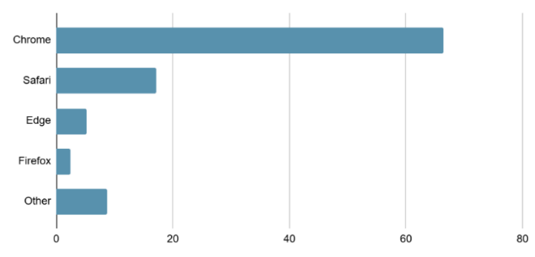
Figure 1. Comparison Chart of Main Web Browser Usage Shares as of May 2025
1.5 Defining the Animation Rendering Process
After a full-page load and an initial rendering, modern browsers engage in a continuous cycle of interface updates and repaints. CSS animations occur within this cycle and are processed according to the browser engine architecture. The general execution cycle of CSS animations based on the Cr rendering architecture is presented below:

1.5.1 Animation Initialization
When CSS animation or transition is applied to an element, the browser processes it by determining the properties involved in the animation, generating keyframes, and creating a timeline [5]. Moreover, it analyzes whether the animation can be GPU-accelerated (e.g., for transformation or opacity). This step is critical for determining whether an animation runs on the main or composite thread [6].

1.5.2 Compositor Thread
If animated properties permit (e.g., opacity, transform, and filter), the browser hands-off animation processing to the compositor thread, avoiding repainting and layout recalculation. This reduces the load on the main thread, avoids unnecessary layout and painting operations, and increases the performance via GPU usage [7].

1.5.3 Animation Update
For each frame iteration (usually 60fps ≈ 16.66ms per frame), the browser: interpolates current animated property values, updates the layer state bound to the element, if the element is on a GPU layer, it sends the frame to the Viz compositor, if repaint is required, runs the whole cycle: layout → paint → composite.

1.5.4 Visual Compositing
In the Viz compositor stage (chromium compositing system), the final frame is assembled by combining the visual elements of the current page, elements from other processes (e.g., iframes and ads), and browser UI elements. The final composite frame is sent to the GPU for display [8].

1.5.5 Animation Completion
At the end of the animation timeline, the element achieves its final CSS property value, and events such as animation or transition ends are triggered [9], [10]. This approach highlights the significance of selecting CSS properties optimized for GPU performance. For instance, attributes such as transformation and opacity can be executed directly by a GPU, thereby enabling them to circumvent the main thread. Conversely, attributes such as width, height, or left necessitate comprehensive recalculations of the DOM and styles, potentially dramatically enhancing the performance [11].

1.6 Contribution and Novelty
This study contributes to the field by evaluating the performance of CSS animations and transitions across varying numbers of animated elements, and covers low-load to high-load conditions. These results provide quantitative data that can serve as a basis for future research based on modern frameworks. All collected and processed metric data were median values and were tested using the null hypothesis. The results reveal actionable metrics, including frame stability, memory consumption, and battery efficiency, which assist developers with practical guidelines for selecting optimal animation techniques based on performance criteria.

- RELATED WORK
Previous studies have compared animation methods, but most of them focused on approaches using JavaScript or analysing animation performance without a direct comparison between CSS animations and transitions [12], [13]. The performance of web animation remains an ongoing topic among professionals; however, few academic studies have quantitatively evaluated CSS transitions and animation techniques. Most existing resources provide advice in a practical field appearing in the form of technical blog articles, such as CSS-Tricks, Smashing Magazine, and MDN Web Docs, which provide usage recommendations, but often lack rigorous empirical validation.
Research related to web interface performance optimization usually discusses aspects such as the impact of DOM operations on rendering, the use of GPU acceleration, and optimizing repaint and reflow [14]. However, these studies seldom focused on comparing animation methods under high load conditions. Some researchers have analysed the effects of specific CSS properties on performance, such as transformation and opacity, which are known to be GPU-friendly [2]. Nonetheless, these studies usually refer to a limited number of elements and do not address the large-scale scenarios commonly used in modern interfaces.
One of the related works is a study Rudramani Bhutia, titled “Optimizing Web Interfaces with AI-Generated CSS Through Machine Learning and Deep Learning,” It explores how machine learning can automate the generation and optimization of CSS codes [15]. While this work does not directly focus on performance testing under load, it is conceptually related to the broader challenge of identifying optimal styling strategies for responsive and efficient web interfaces, and displays the growing interest in intelligent tools for interface optimization, including those that operate on animations.
Another relevant contribution to the topic is the study by Venkata Padma Kumar Vemuri, titled “addressing Critical Challenges in Front-End Performance and Scalability” [16]. It addresses the identification and mitigation of key bottlenecks in modern front-end development, including the DOM complexity, excessive script execution, and inefficient rendering paths. The article does not compare animation approaches, but emphasizes the importance of minimizing layout thrashing and reflow, which are directly impacted by how CSS animations and transitions have been implemented. In addition, it consolidates optimal strategies for enhancing runtime performance and scalability, particularly in interfaces characterized by high interaction rates and dynamic content updates, akin to the high-load animation scenarios examined in this research.
Another relevant article to the topic is the study by Yifan Yang, titled “Web Front-End Application Performance Improvement Method Based on Component-Based Architecture”. It investigates structural optimization strategies to enhance web front-end performance; identifies key bottlenecks such as rendering, network latency, and inefficient resource handling; and offers a modular component-based architecture as a solution [17]. By introducing techniques such as lazy loading, code splitting, and efficient state management, this study demonstrates how well-structured front-end architectures can significantly improve the runtime performance. Although this paper does not directly provide an analysis of CSS animations, the principles outlined apply to animation-heavy interfaces, especially in scenarios requiring scalable and maintainable performance under load.

- RESEARCH METHODOLOGY
This study outlines the testing environment and identifies the principal functionalities utilized by the application. This provides a comprehensive description of the experimental configuration and research methodologies used to determine the efficiency of CSS animation methods.

3.1 Research Environment
A Single-Page Application (SPA) was designed and developed to evaluate the rendering performance of various CSS animation techniques. The primary objective of this SPA was to simulate high-load scenarios involving thousands of animated DOM elements, thereby enabling a controlled comparison between the two CSS methods: @keyframes (animations) and transitions. The following metrics were collected during the test execution as the load increased: FPS, delta (frame stability), and JavaScript heap memory consumption [18].
The experimental configuration was designed to isolate the rendering speed from additional browser overheads such as I/O and network delay. This methodology confirms that any variations in performance measures can be directly attributed to animation techniques [19].
The following components were utilized:
- JavaScript Native API: This utilized for direct access to performance-related data, covering memory consumption (via the performance memory property), frame timings (via the requestAnimationFrame method), and high-resolution timestamps (utilizing the performance method) [20], [21].
- Vue.js: A reactive front-end framework is utilized to construct an SPA interface and oversee the lifecycle events of DOM elements [22]. Vue's declarative rendering paradigm and the optimized virtual DOM make it ideal for performance-critical applications.
- Pinia: A contemporary and streamlined state management library connected to Vue, utilized for storing test parameters (such as the chosen animation type and block quantity) while capturing real-time performance metric updates. The reactive architecture facilitates the synchronization of data gathering with rendering cycles [23].
- VueUse: A utility library that enhances Vue's Composition API with performance-related hooks. The following utilities were utilized: useFps – measures real-time and minimum FPS throughout the animation lifecycle; useMemory – tracks current JavaScript heap usage, allowing for monitoring of memory allocation growth during test runs; and useRafFn – registers a requestAnimationFrame loop that calculates per-frame time deltas and executes metric update callbacks immediately at the start of each frame [24].
The application should store all collected performance metrics across all tests in the reactive state stores. In addition, it is designed to avoid layout thrashing and forced reflows, which can artificially skew FPS measurements and negatively impact the rendering performance. In addition, to replicate realistic UI animation patterns, DOM elements were styled using hardware-accelerated CSS properties such as transformation and opacity. This approach utilizes GPU acceleration, which allows the tests to closely mirror typical production scenarios in which smooth animations are crucial for UX.

3.2 Research Process
The practical part of the research consists of the following steps:
- Set up configuration: preparing test elements and resetting previous test data.
- Collect baseline (initial) metrics data.
- Run the test based using the prepared configuration while collecting performance metrics data.
  - Run transitions test based on N-elements.
  - Run animation test based on N-elements.
  - Prepare report.
- Modify the test configuration and repeat the process from step 2.
The workflow described is illustrated in Figure 2.
Every test dynamically generated between 50 and 10,000 DOM elements, each subject to synchronized CSS animations or transitions, simulating high-stress UI scenarios that are typical of modern web applications.
The source code and demo stage are publicly accessible:
- Live test app: https://performance-test-c0478c.gitlab.io
- Source code repository: https://gitlab.com/senior-debugger/performance-test

- EXPERIMENTAL SETUP
The experimental configuration was designed to simulate real-world web application conditions and to guarantee consistency across various interface loads. All measurements were conducted in a controlled environment to isolate animation performances from external system activities.
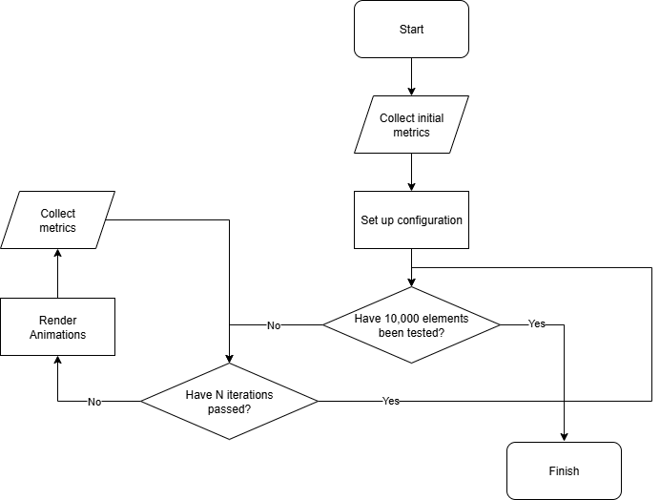
Figure 2. Animation Performance Testing Workflow

  - Hardware and Software Configuration
The experiments were executed on a Windows 11 Pro workstation (ASUS ProArt P16) equipped with high-performance components optimized for intensive graphics and computational tasks.
- CPU: Intel Core i9-13980HX, a premier multicore processor providing outstanding single-thread and multithread performance, guaranteeing minimal CPU bottlenecks during the rendering evaluations.
- GPU: NVIDIA RTX 4070 Laptop GPU (8GB VRAM), proficient in hardware-accelerated rendering and GPU compositing, is crucial for authentic simulation of animation tasks using contemporary browser-rendering frameworks.
- RAM: 32 GB DDR5, offering sufficient memory to prevent swapping or resource conflicts that may distort the JavaScript heap metrics.
- Display: 16” OLED (3840×2400, 60 Hz), providing precise colour accuracy and refresh rates to render animation frame timing accurately.
All tests utilized the latest stable versions of Google Chrome (v138.0.7204.184) and Mozilla Firefox (v141.0.2). Both were selected because of their cross-platform popularity and configured with hardware acceleration to utilize GPU composition. The advanced APIs of Chrome enabled comprehensive performance assessments, whereas cross-validation with Firefox verified that the results were not artifacts specific to any browser. Uniform measures across browsers strengthened the reliability and applicability of our findings. Platform-specific rendering engine optimization and hardware drivers may affect the absolute performance results; therefore, they should be understood within the context of the testing environment.

- IMPLEMENTATION
This section describes the experimental implementation steps and features of the test environment used to evaluate the performance of the various CSS animation methods.

5.1 Test Configuration
The initial stage of testing involves configuring the environmental parameters. Web applications provide a graphical interface to configure test conditions: the type of animation (either animation or transition), specifies the number of blocks to animate (ranging from 1 to 10,000), and selects one of the predefined sets of animation properties (such as opacity, transform, blur, and background colour).

5.2 Test Execution
After configuring the settings, the user initiates the test run. In the next step, the application enters active testing mode. At this point, each animated element is considered and the corresponding CSS mechanism, either animation or transition, is triggered simultaneously.
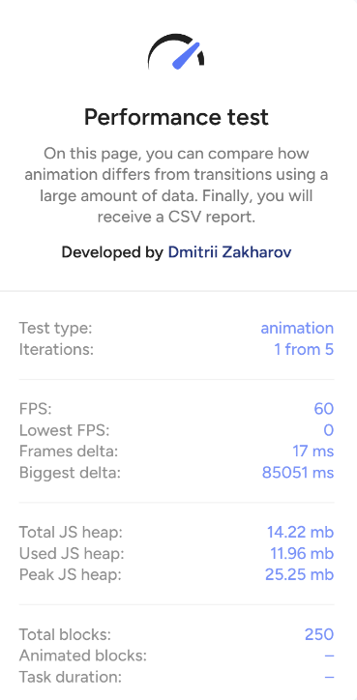
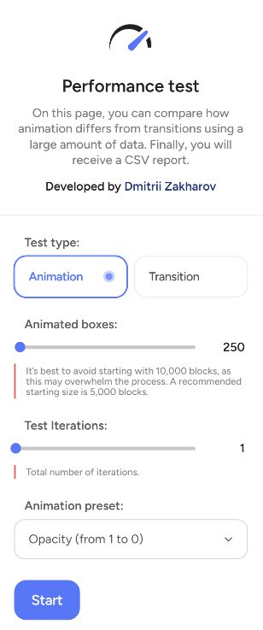
Throughout the test, the system continuously monitored the key browser metrics in real time, including the current FPS, delta (frame stability) peak JavaScript heap usage, and other parameters that characterize the rendering performance. To measure these metrics, built-in browser APIs were called using JavaScript [5]. The collected data allowed for a direct comparison of the efficiency of the two CSS animation mechanisms based on the workload and properties being animated during the test. A graphical interface for this stage is shown in Figure 3.
(a) | (b)
Figure 3. Graphical User Interface of the Load Testing Environment: (a) Data Input Stage, (b) Testing Page

- RESULTS AND DISCUSSIONS
The test data were collected over 50 iterations during the testing phase, resulting in an average value that did not account for the deviations. The median is calculated for each data point to mitigate the impact of outliers and distortions, thereby providing a smoother representation of the data.

  - Implementation of Animated Blocks: 50 Units, with Low Complexity
This serves as the basis for establishing metrics on a minimal test set. The charts in Figure 4 illustrate the performance metrics related to CSS animations and transitions, including frame duration, FPS, and memory consumption.
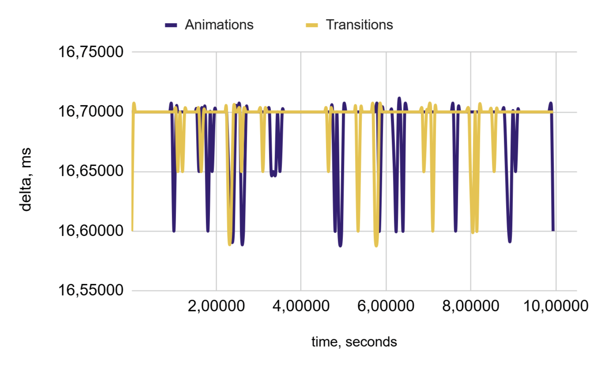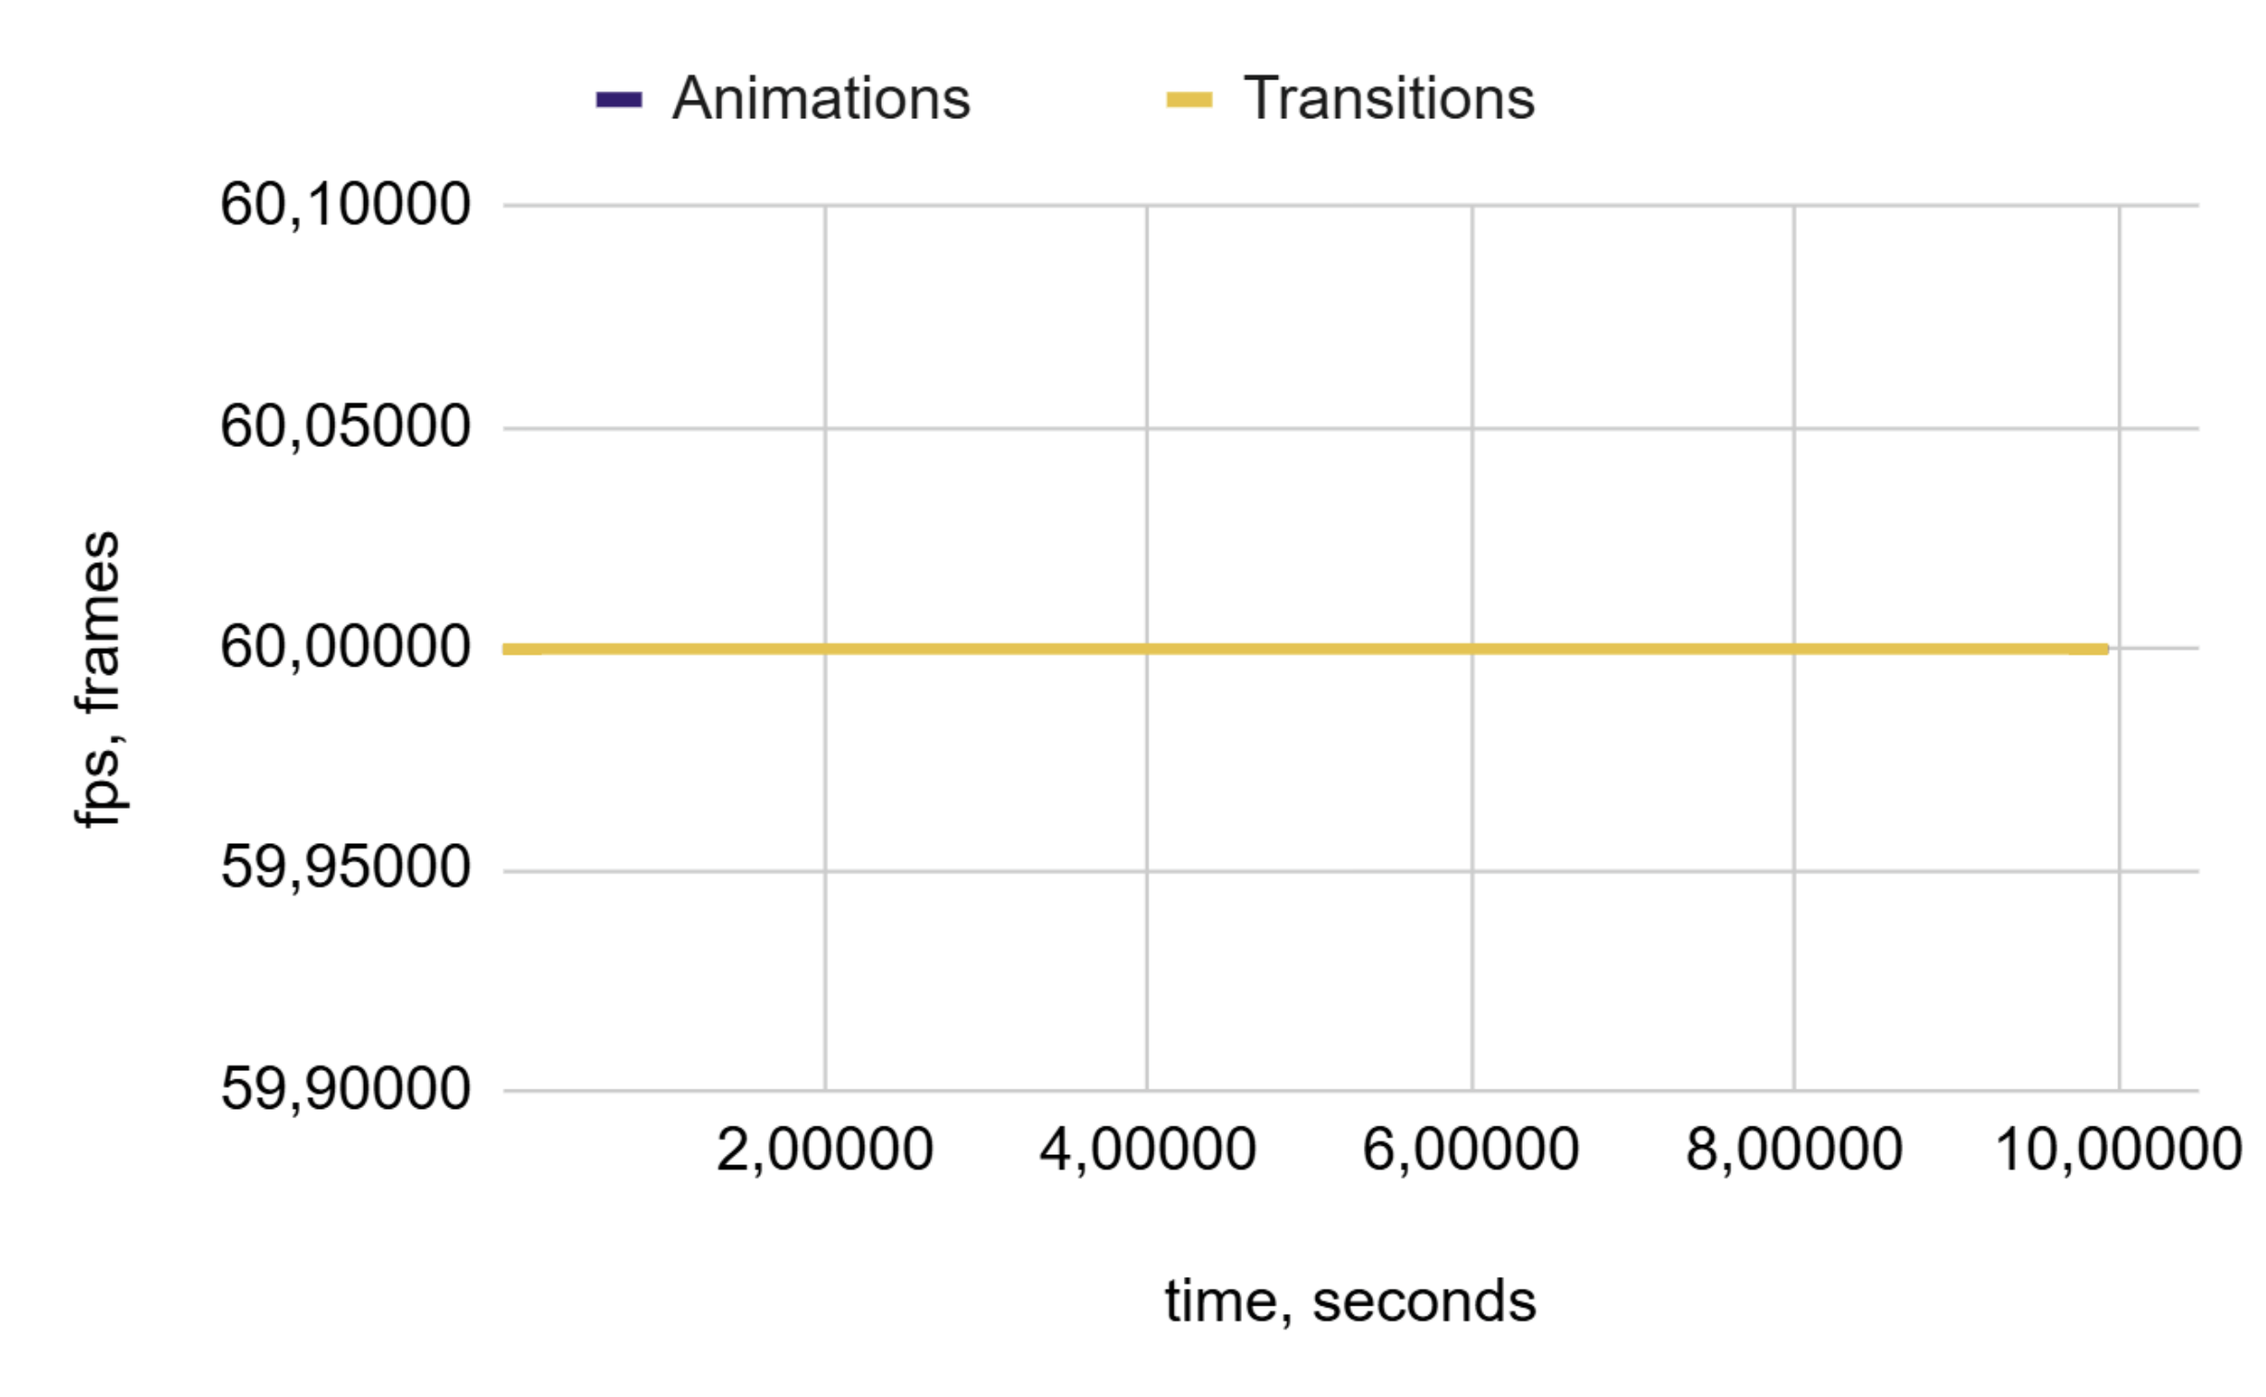
(a) | (b)
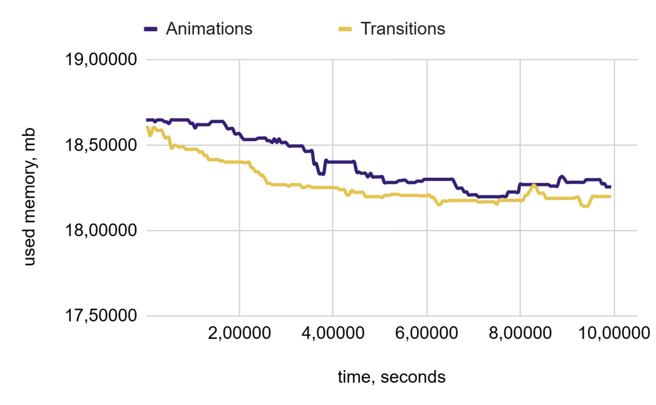
(c)
Figure 4. Performance Charts for 50 Blocks: (a) Frame Duration, (b) FPS, and (c) Memory Consumption

In the subsequent analysis, we evaluated the performance of animations in comparison to transitions by calculating their relative values. To facilitate this assessment, we employed Equation (1):
$$\sum_{i=1}^{N}{\frac{({mt}_{i}^{a}-{mt}_{i}^{t})}{{mt}_{i}^{a}}}$$ | (1)
Where:
- $N$ = estimated number of iterations.
- ${mt}_{i}^{a}$ – current metric, which can be memory, delta, or FPS.
The memory consumption was 0.66%, indicating that more memory was utilized compared to the transitions. The FPS is currently 0%, and the delta is -0.02%, suggesting that the FPS is lower than it was during the transitions. However, overall, there was no significant difference in FPS, as these values were close to zero. In this study, we used a more complex dataset.

  - Implementation of Animated Blocks: 250 Units, with Low Complexity
The test results obtained under low-load conditions, specifically with 250 animated blocks, were analysed. The charts illustrated in Figure 5 display the behaviour of the key performance metrics when CSS animations and transitions are used.

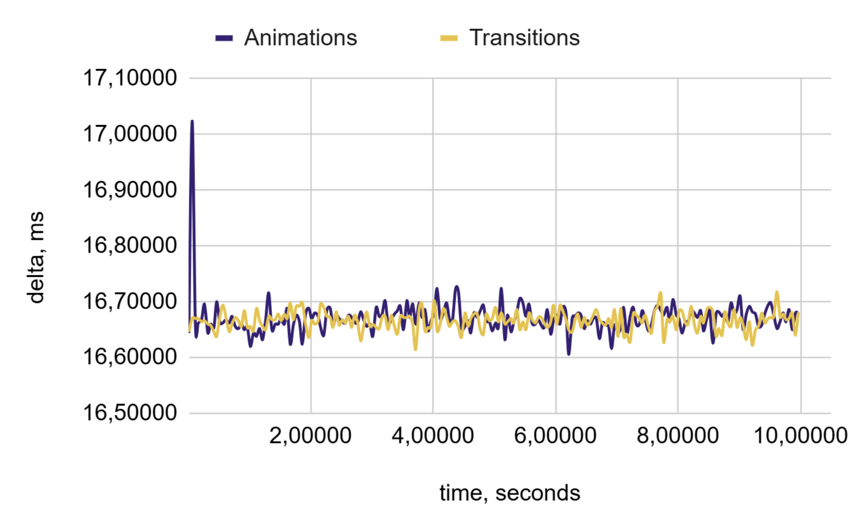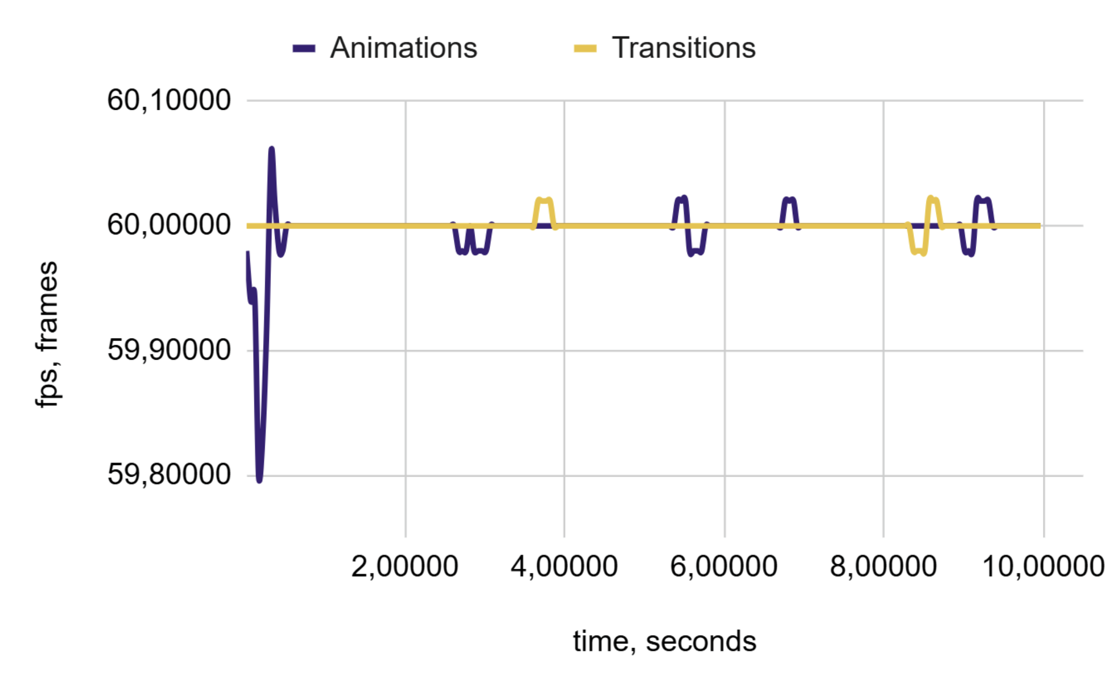
(a) | (b)
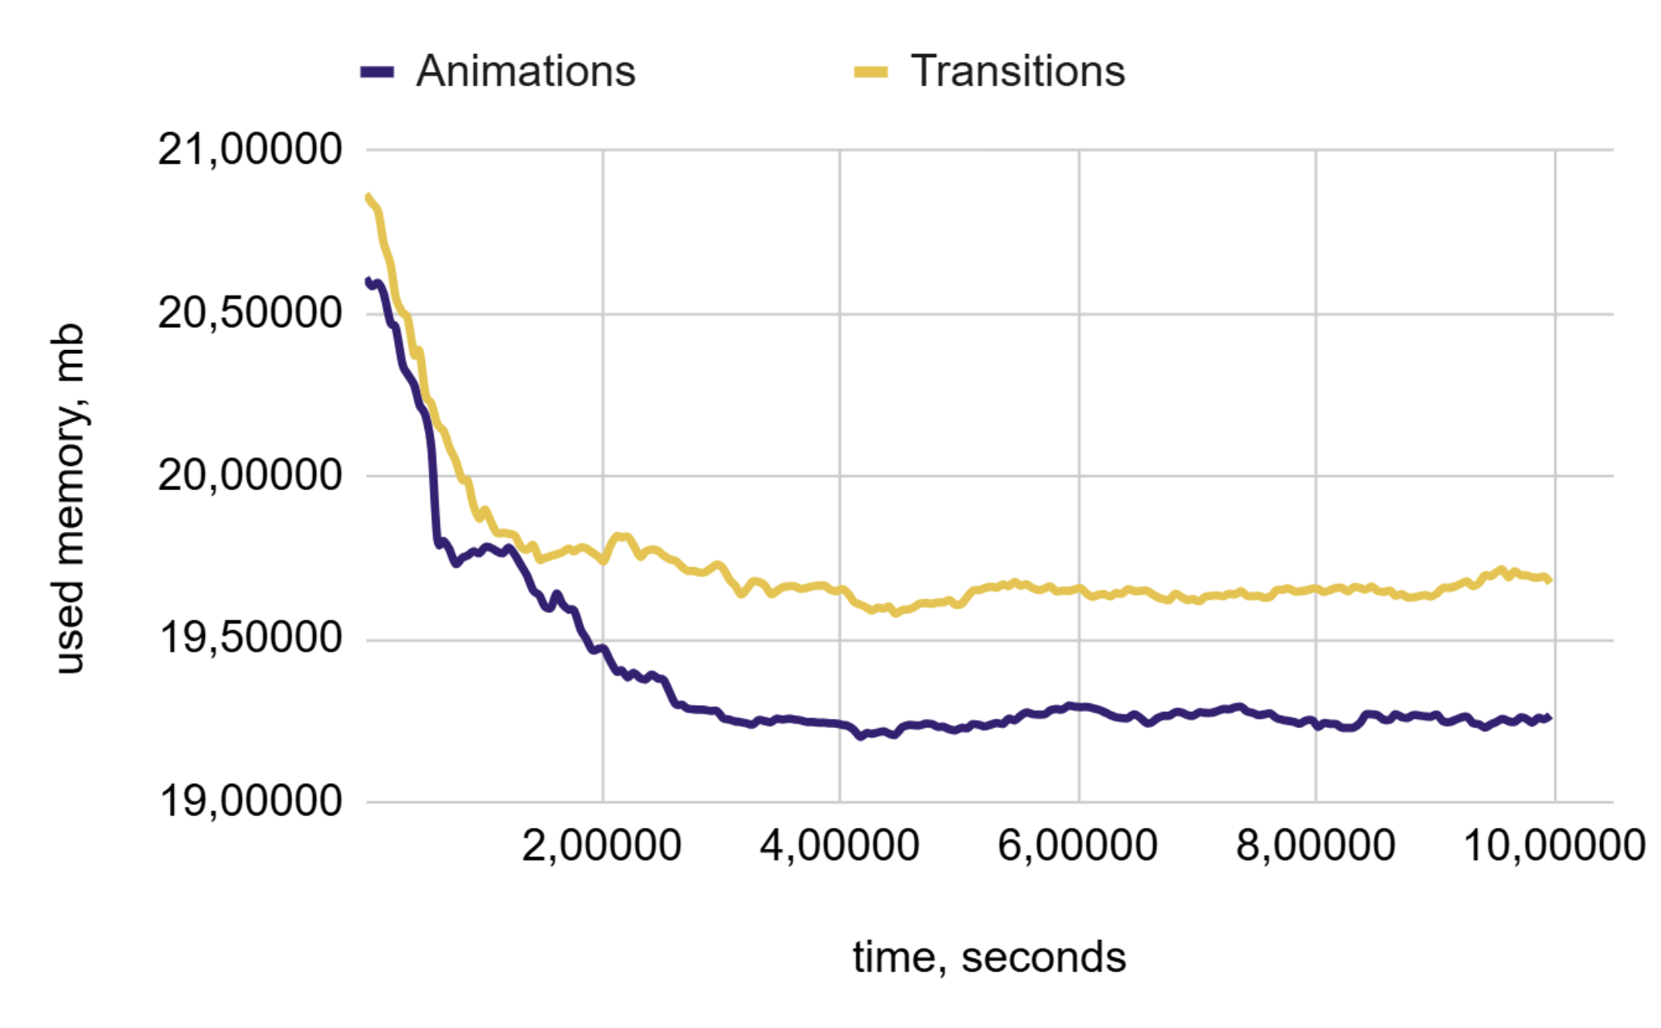
(c)
Figure 5. Performance Charts for 250 Blocks: (a) Frame Duration, (b) FPS, and (c) Memory Consumption
The memory consumption was − -1.181%, indicating that less memory was used compared to transitions. The FPS was -0.004% with a delta of 0.02%, suggesting that the FPS was slightly lower than that during the transitions. However, the overall difference in FPS was not significant, as these values were close to zero. In this study, we used a more complex dataset.

  - Implementation of Animated Blocks: 500 Units, with Low Complexity
The test results obtained under low-load conditions, specifically with 500 animated blocks, were analysed. The charts in Figure 6 illustrate the behaviour of the key performance metrics when CSS animations and transitions are used.
The memory consumption is 0.53%, which indicates that more memory is consumed compared with transitions. The FPS is currently − -0.01%, with a delta of 0.03%. This suggests that the FPS was lower during the transitions. However, overall, there was no significant difference in FPS, as these values were close to zero. In this study, we used a more complex dataset.

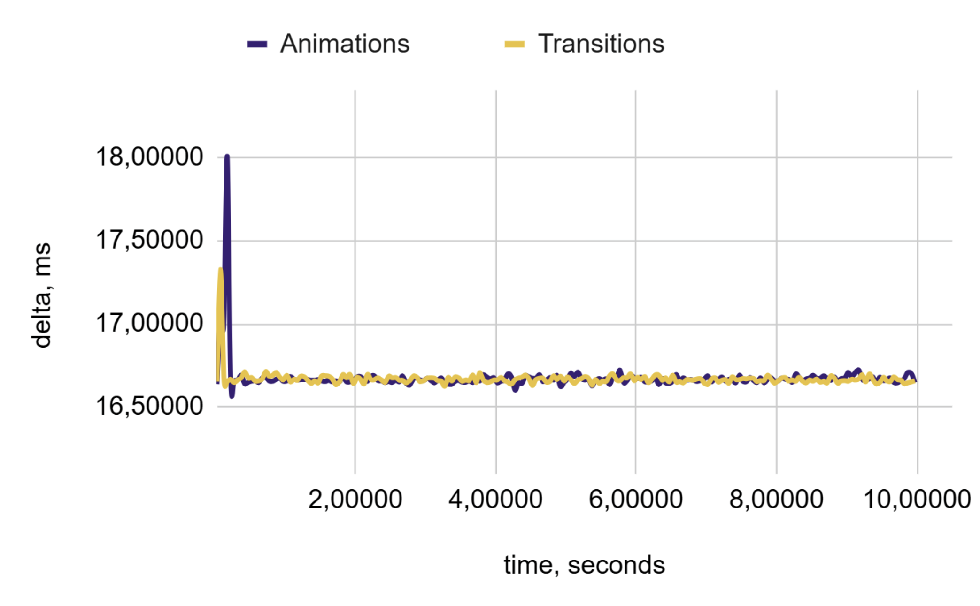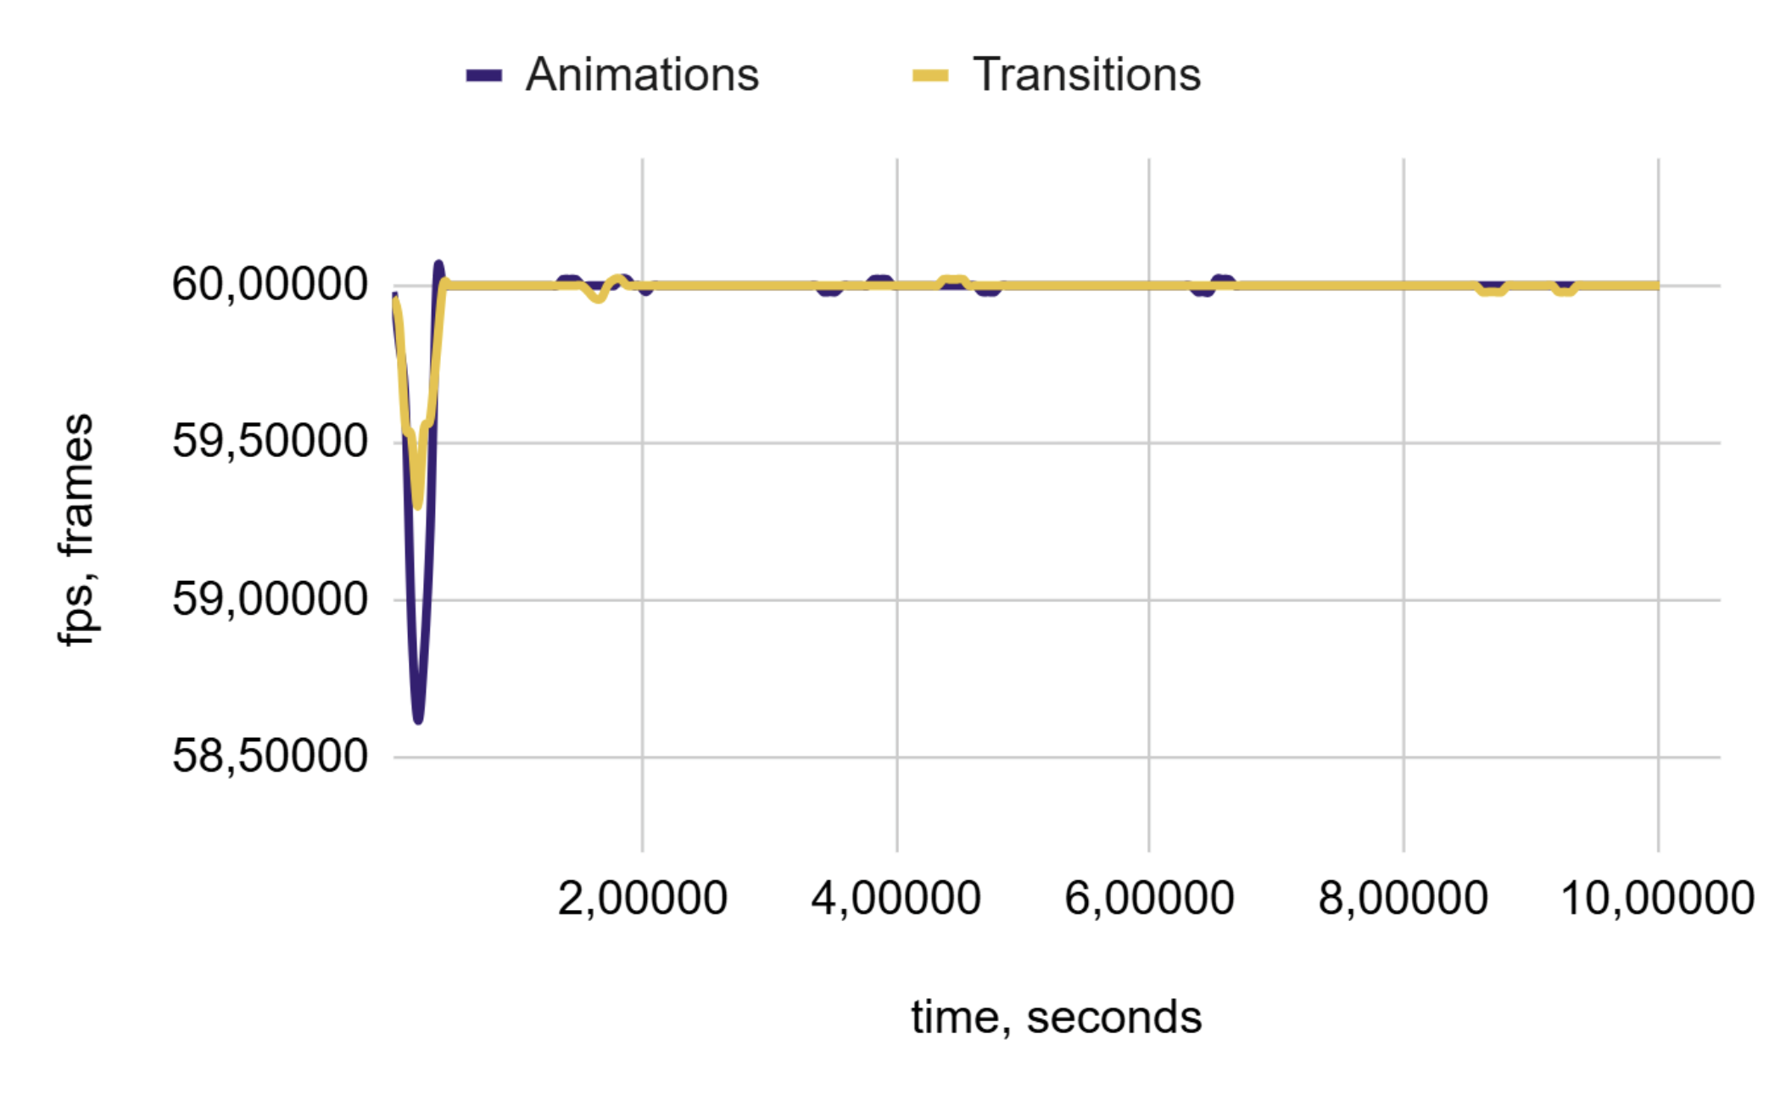
(a) | (b)
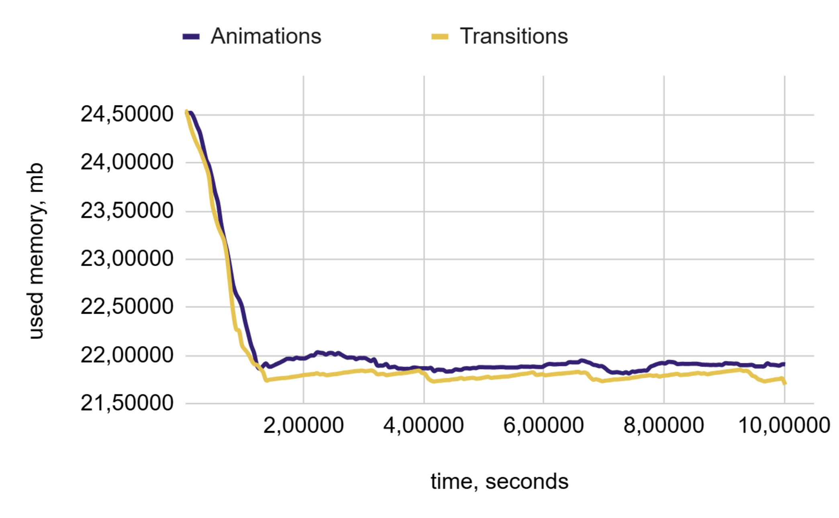
(c)
Figure 6. Performance Charts for 500 blocks: (a) Frame Duration, (b) FPS, and (c) Memory Consumption

  - Implementation of Animated Blocks: 1,000 Units, with Low Complexity
The test results obtained under increased load conditions, specifically with 1,000 animated blocks, were analysed. Although this setup places greater demands on system resources, it still falls within the range of moderate computational complexity. The charts in Figure 7 illustrate the performance metrics for the CSS animations and transitions.
The memory consumption was 1.40%, indicating that more memory was being utilized compared to during transitions. The FPS decreased by 0.05%, and the delta decreased by 0.02%. This suggests that the FPS was lower than that during the transitions. However, overall, the difference in the FPS was not substantial, as these values were close to zero. In this study, we used a more complex dataset.

  - Implementation of Animated Blocks: 2,500 Units, with Low Complexity
The test results obtained under increased load conditions, specifically with 2,500 animated blocks, were analyzed. This testing phase involved a more complex dataset; therefore, a slight discrepancy in the metrics was expected. The charts in Figure 8 illustrate the performance metrics for the CSS animations and transitions.

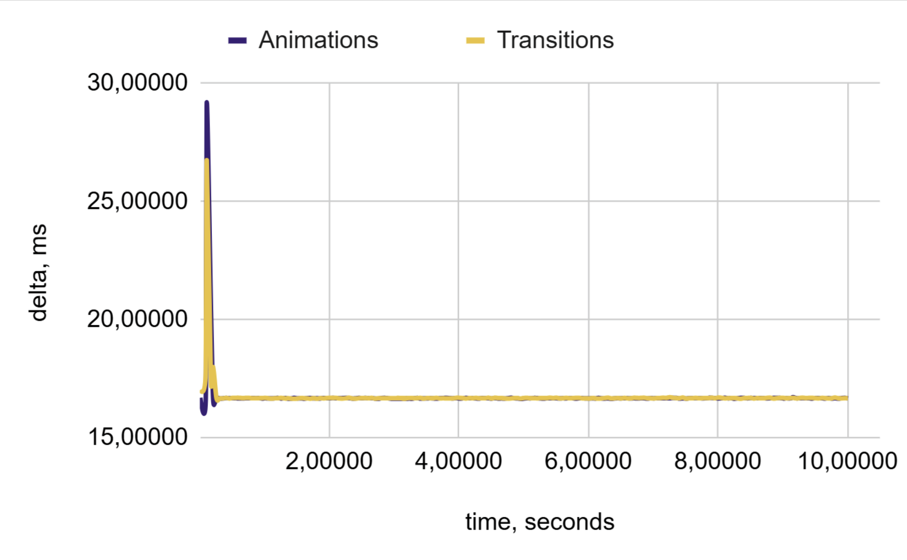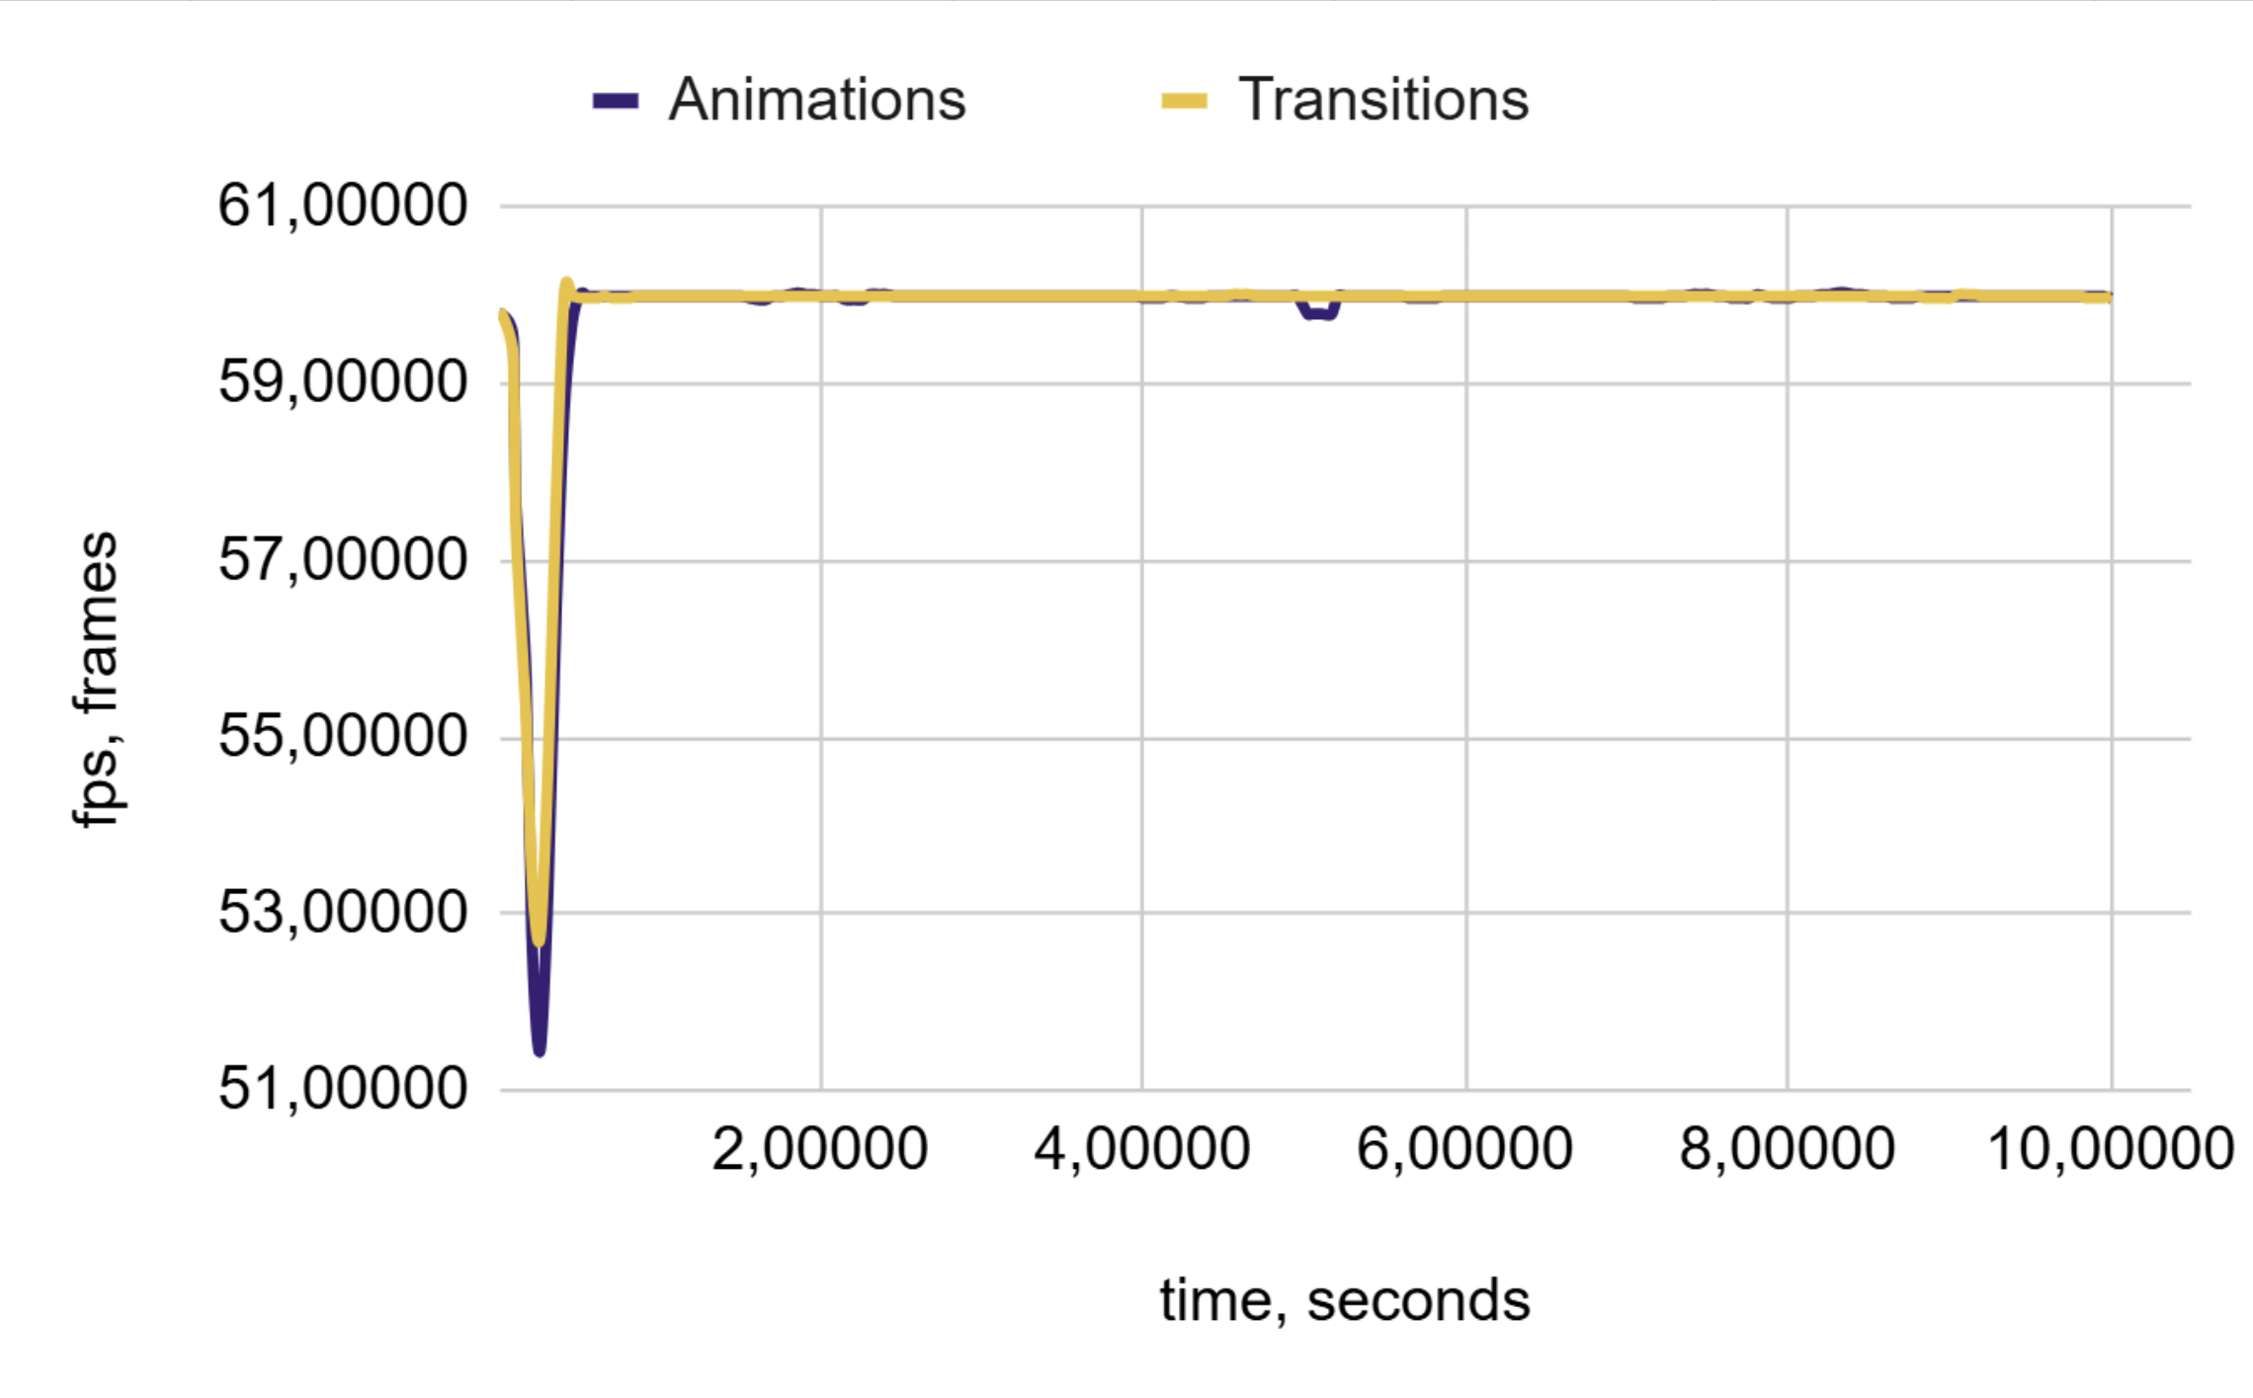
(a) | (b)
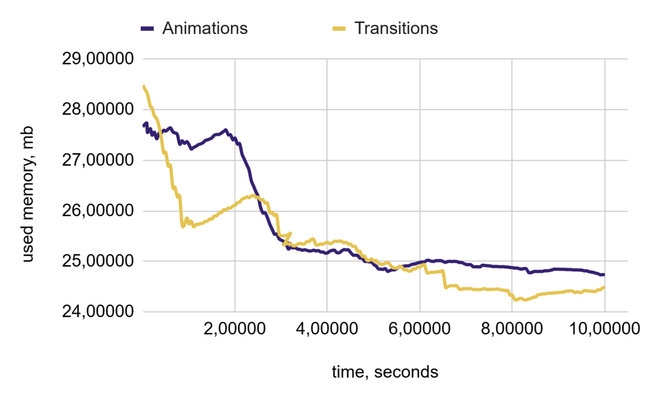
(c)
Figure 7. Performance Charts for 1,000 blocks: (a) Frame Duration, (b) FPS, and (c) Memory Consumption

  - Implementation of Animated Blocks: 5,000 Units, with Low Complexity
The test results obtained under increased load conditions, specifically with 5,000 animated blocks, were analyzed. This group of elements is anticipated to require more memory resources and will likely result in a noticeable decrease in FPS. However, this level of performance is still considered average.
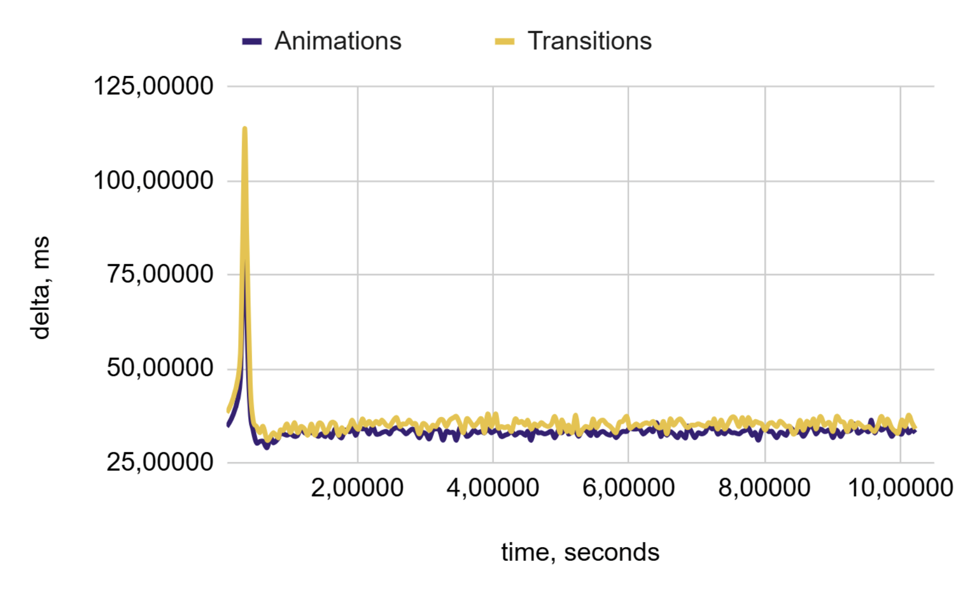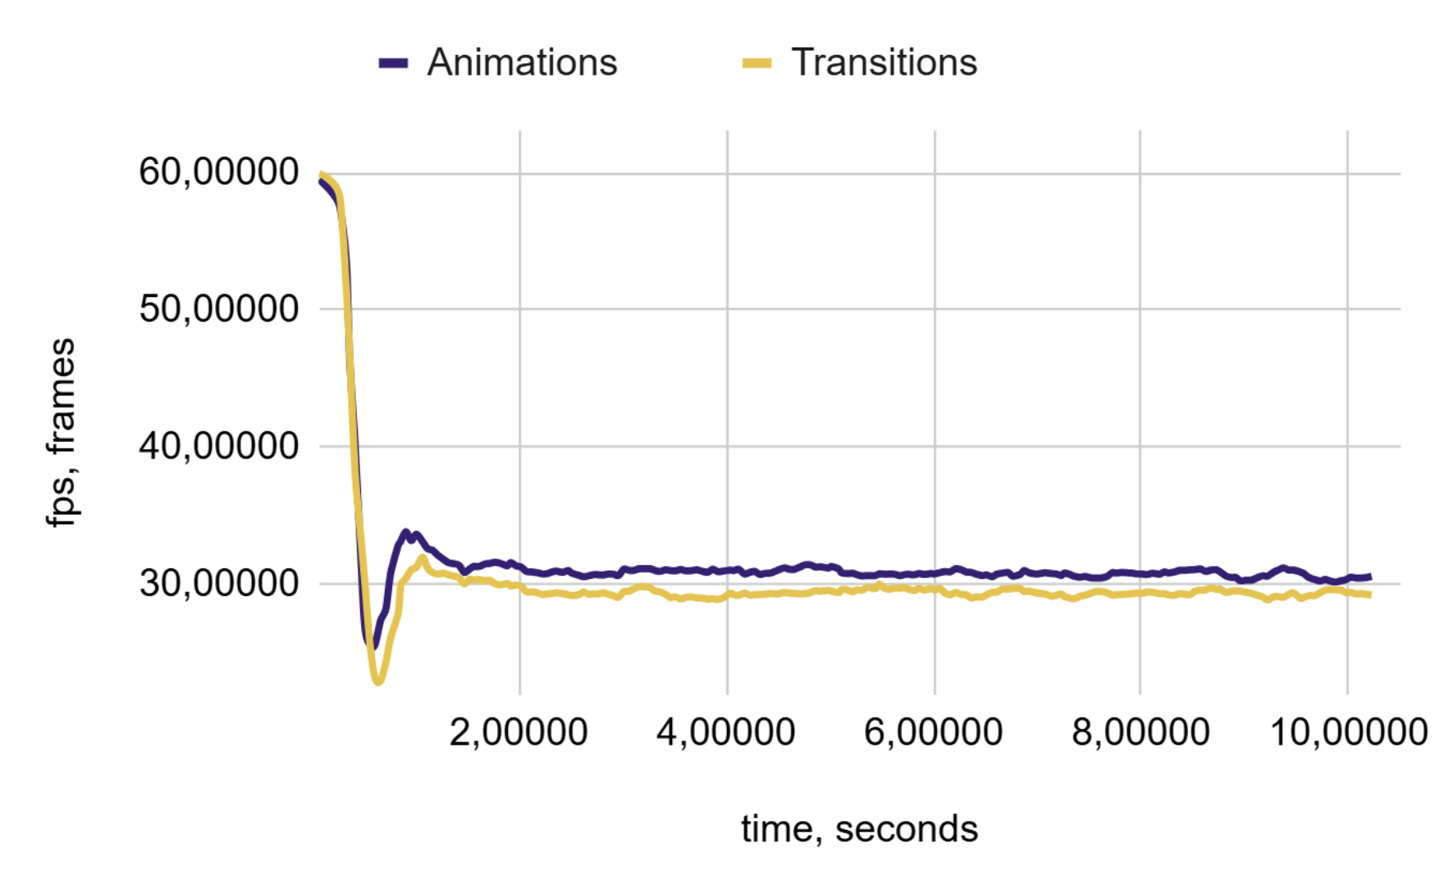
(a) | (b)
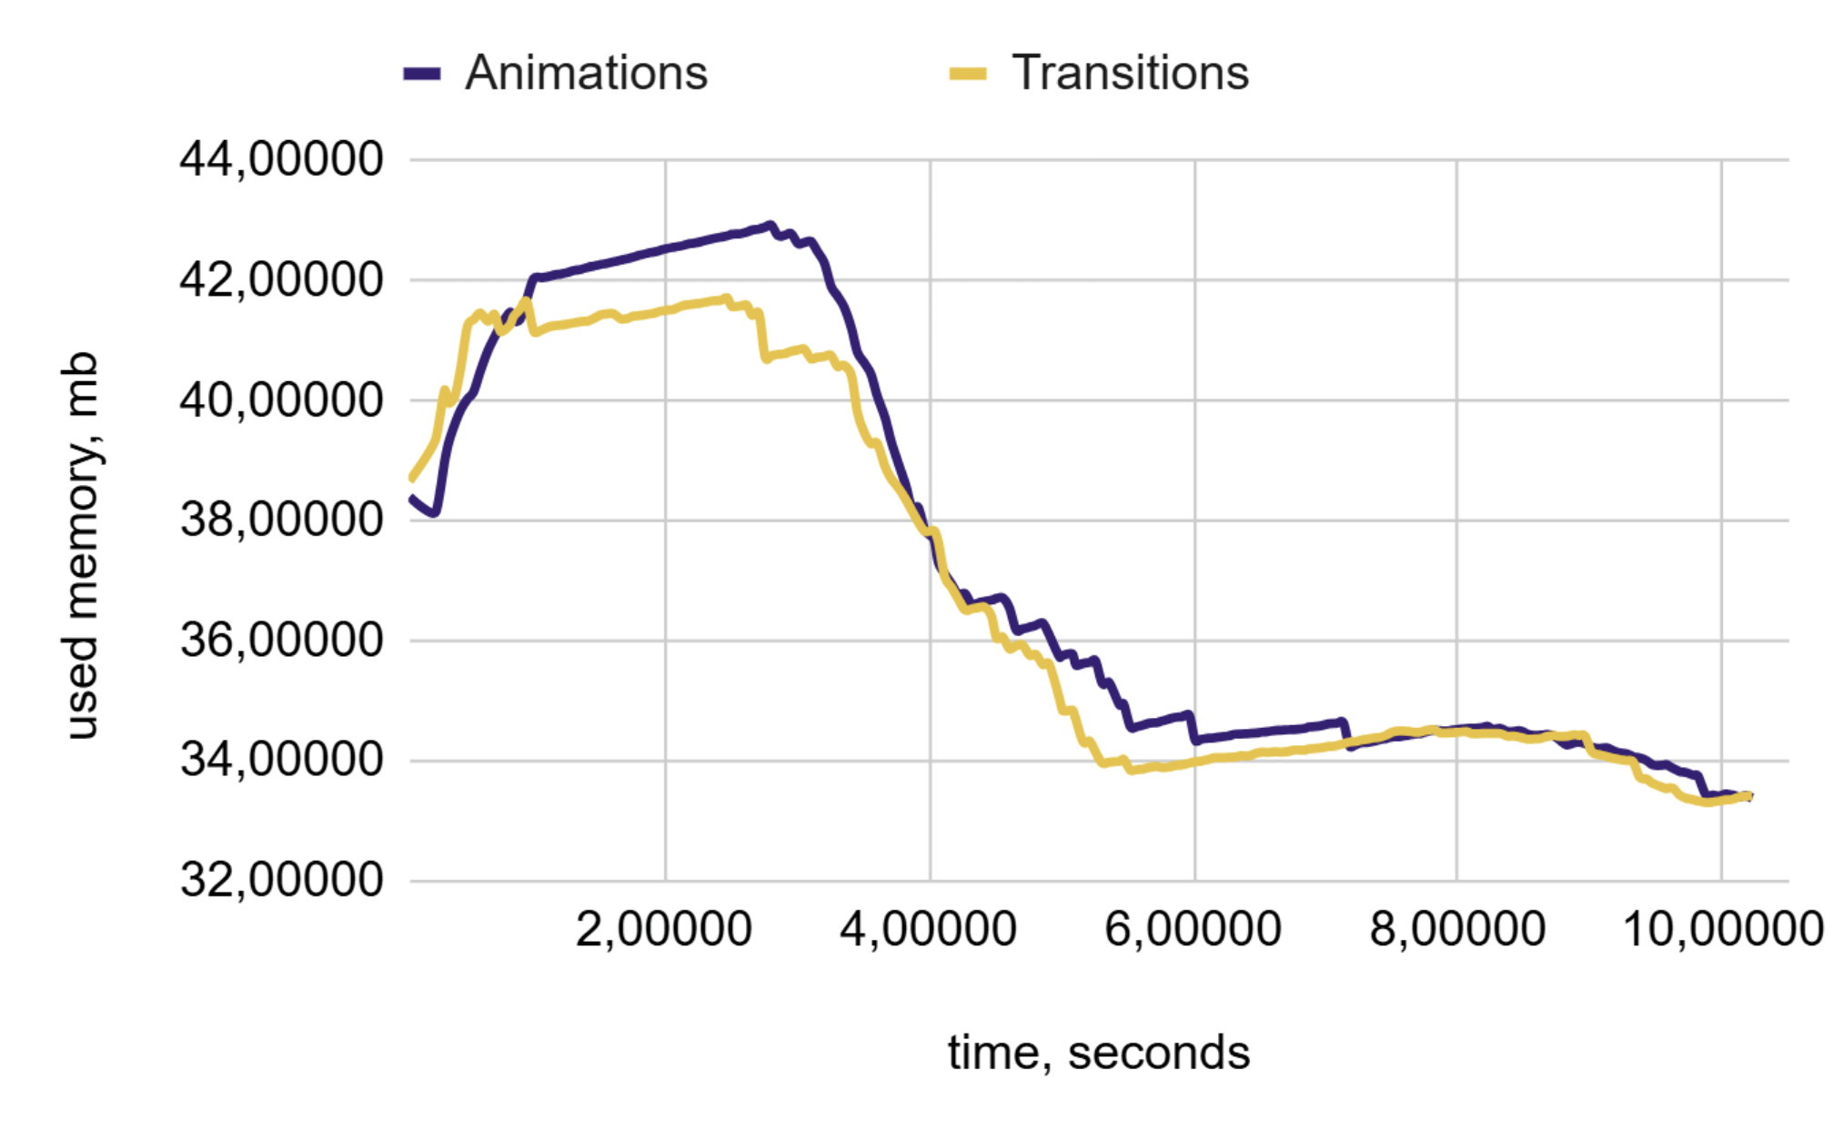
(c)
Figure 8. Performance Charts for 2,500 Blocks: (a) Frame Duration, (b) FPS, and (c) Memory Consumption

The charts in Figure 9 illustrate the performance metrics for CSS animations and transitions.
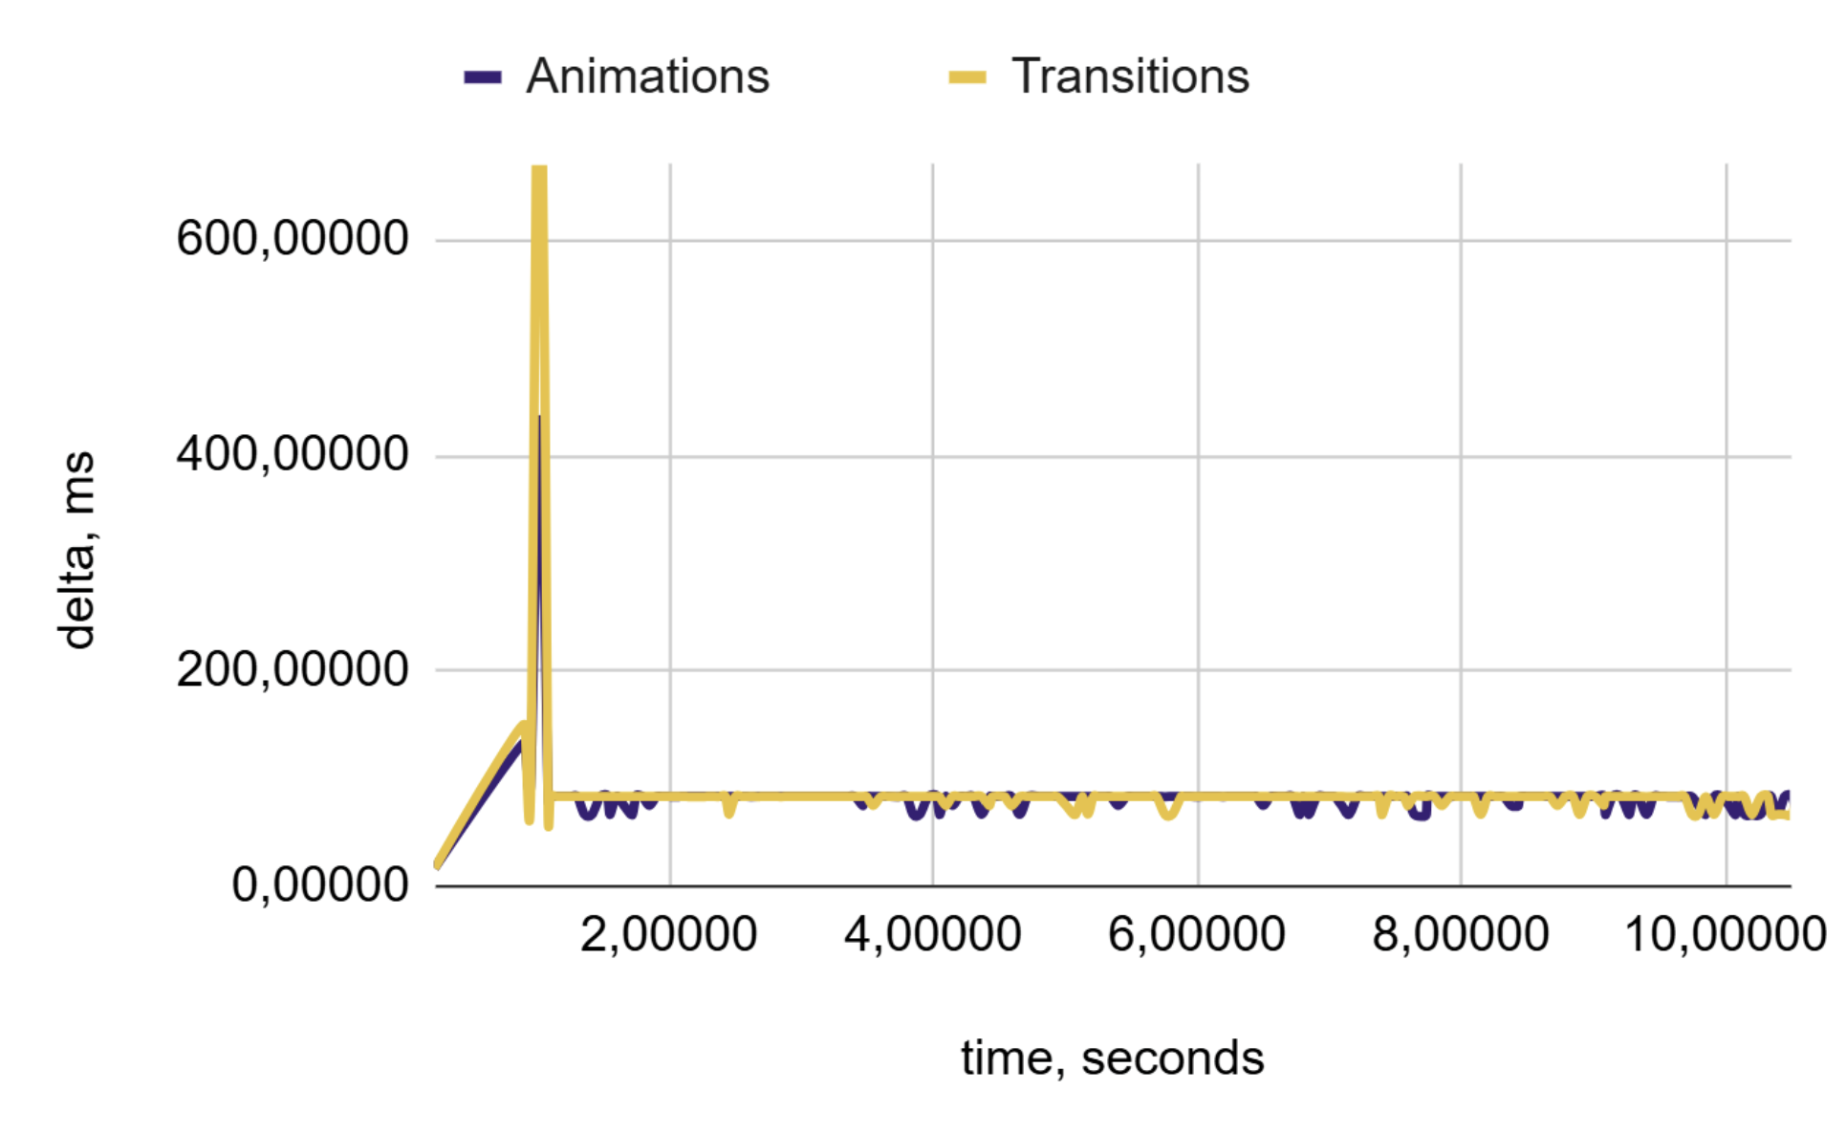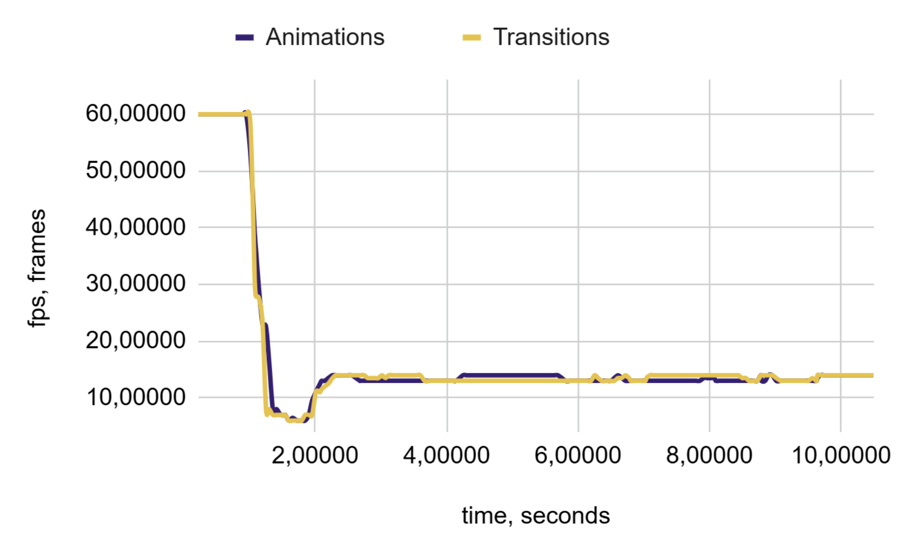
(a) | (b)
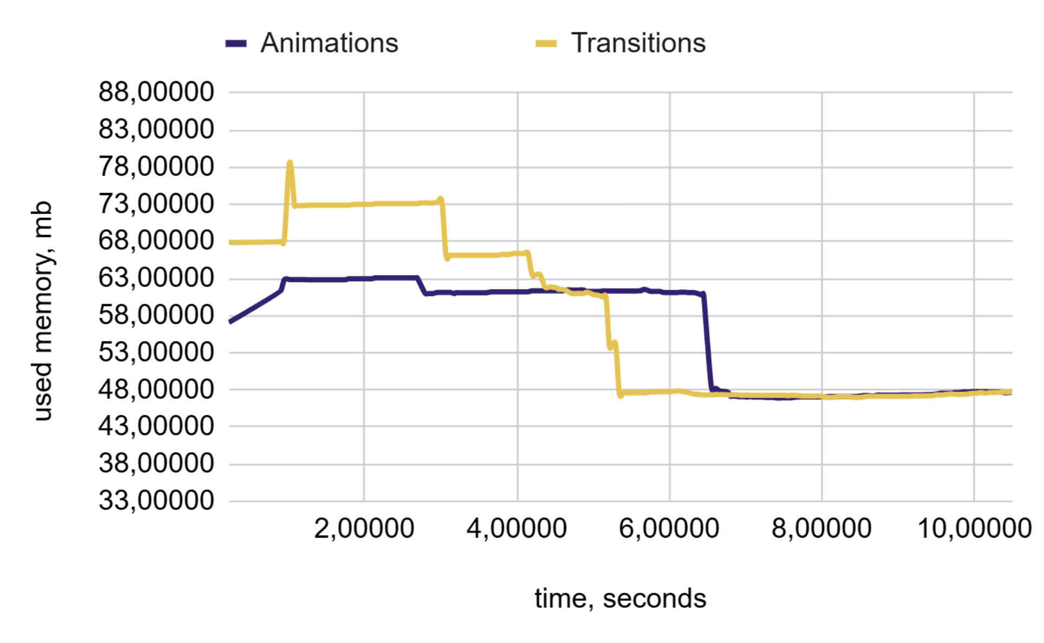
(c)
Figure 9. Performance Charts for 5,000 Blocks: (a) Frame Duration, (b) FPS, and (c) Memory Consumption
Memory consumption metric data decreased to 1.74%, indicating that less memory was being utilized compared to the transition periods, and the frames/second metric data were at 0.51%, with a change of -2.43%, suggesting that the FPS was higher than during the transitions. Significantly, this situation represents ideal testing conditions, where the number of metrics remains consistent and there are no significant declines in performance. In addition, at this stage of testing, the amount of memory required for execution increases from 25% to 100% at various points in time.

  - Implementation of Animated Blocks: 7,500 Units, with Low Complexity
Therefore, more complex datasets should be considered when conducting accurate tests. The test results obtained under increased load conditions were analysed using 7,500 animated blocks. This volume of elements is expected to be high for system resources, leading to a more noticeable reduction in performance metrics.
The charts in Figure 10 illustrate the key metrics for CSS animations and transitions.
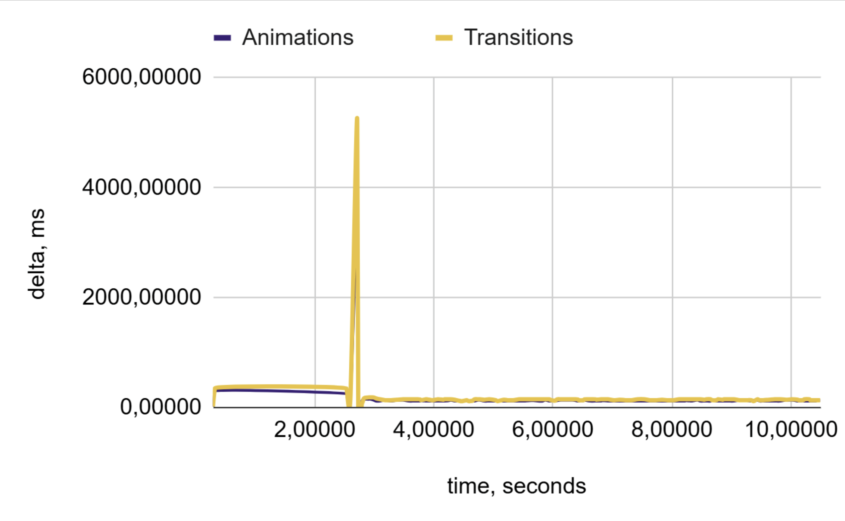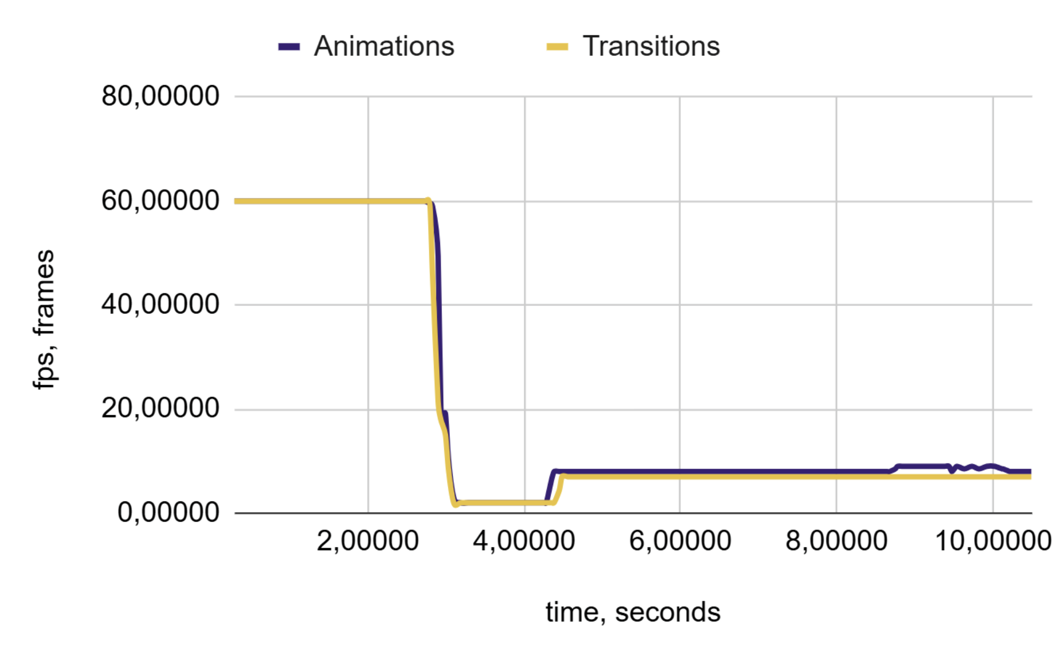
(a) | (b)
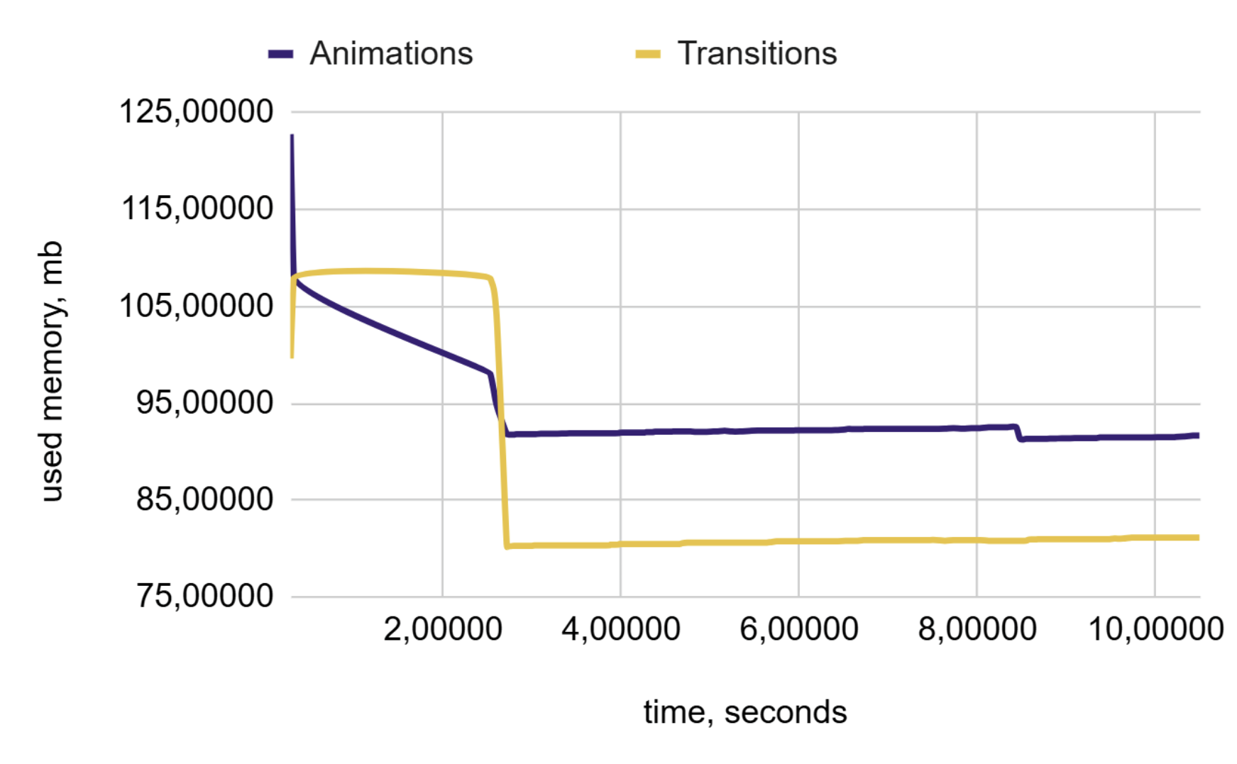
(c)
Figure 10. Performance Charts for 7,500 Blocks: (a) Frame Duration, (b) FPS, and (c) Memory Consumption

Memory consumption increased by 14.11%, indicating higher memory utilization compared with the transition periods. The current FPS was 12.04%, with a delta of -16.80%, suggesting that the FPS was lower than that during the transitions.
Significantly, the amount of memory required, compared to the previous test, was between 25% and 100% higher than in the earlier tests and from 100% to 400% of the measurements taken with 2500 blocks.

  - Implementation of Animated Blocks: 10,000 Units, with Low Complexity
Test results were obtained under high-load conditions using 10,000 animated blocks. This is the maximum threshold for testing; exceeding this limit can result in significant metric losses due to system overload, making the outcomes subjective. At this load level, there may be a loss of frames and metrics because this is very demanding for the browser process. However, this test offers valuable insights into performance differences.
The charts in Figure 11 clearly illustrate the key performance metrics for the CSS animations and transitions.
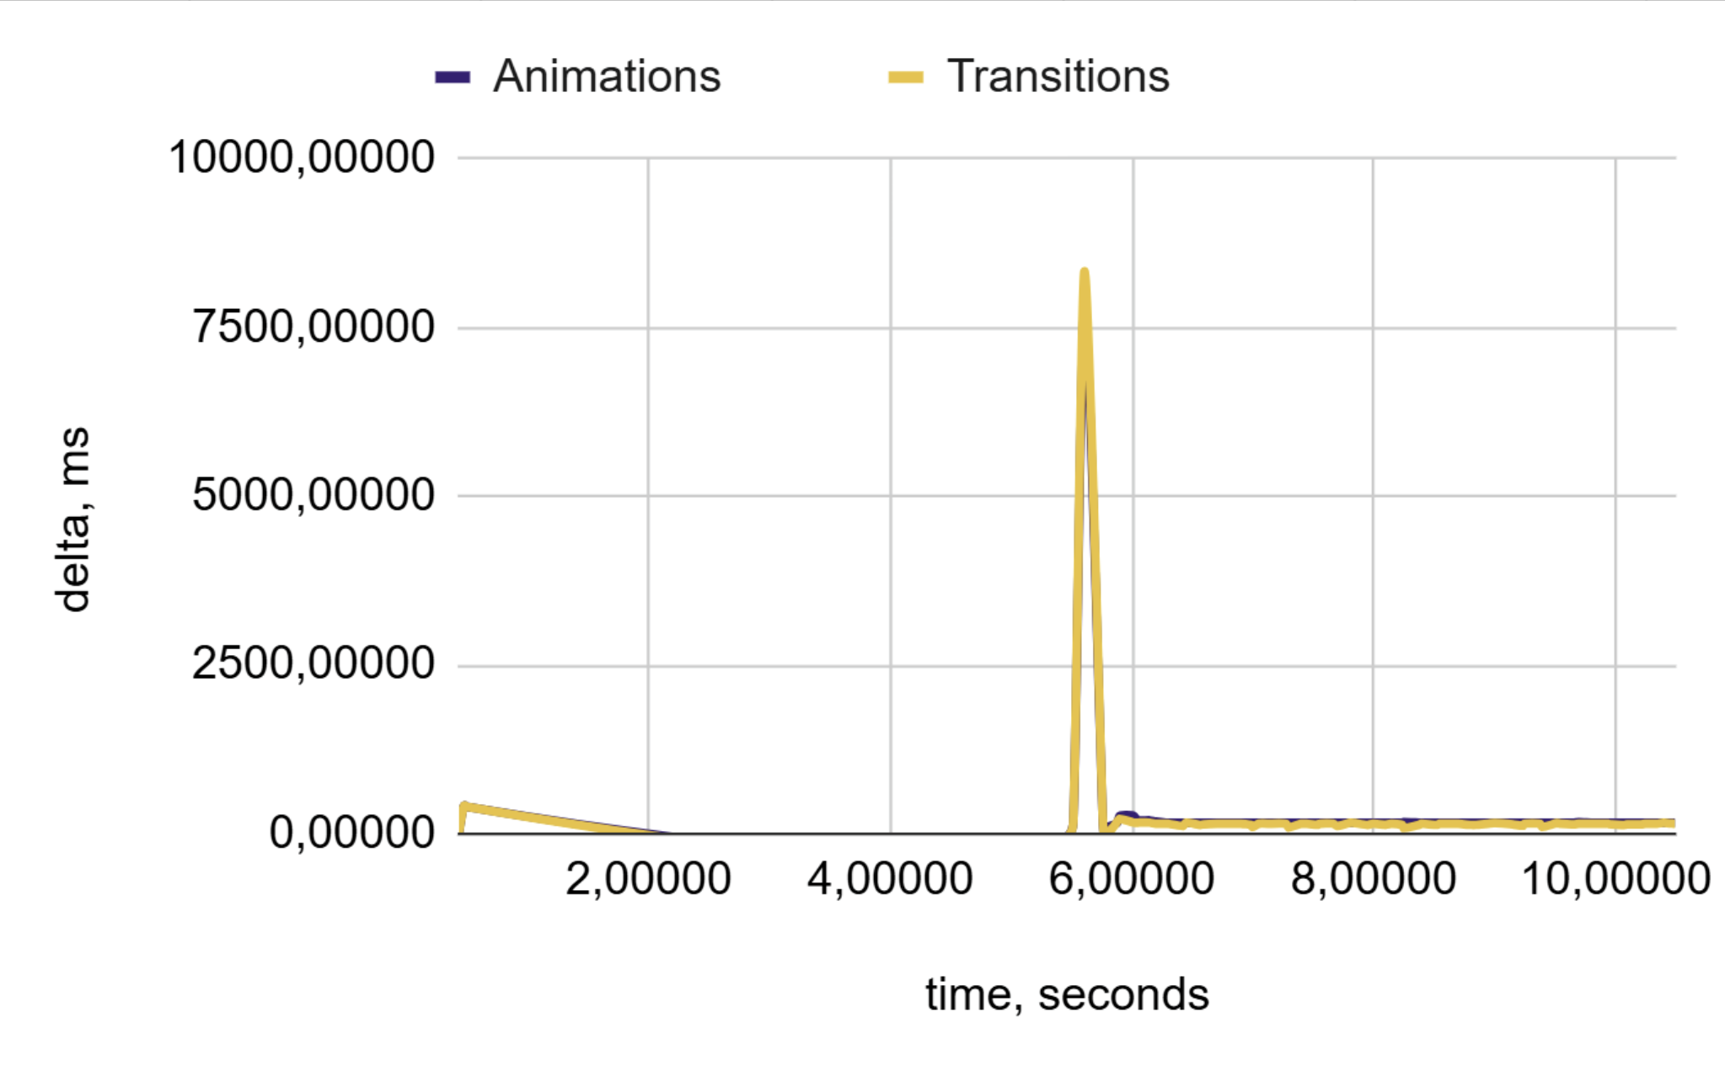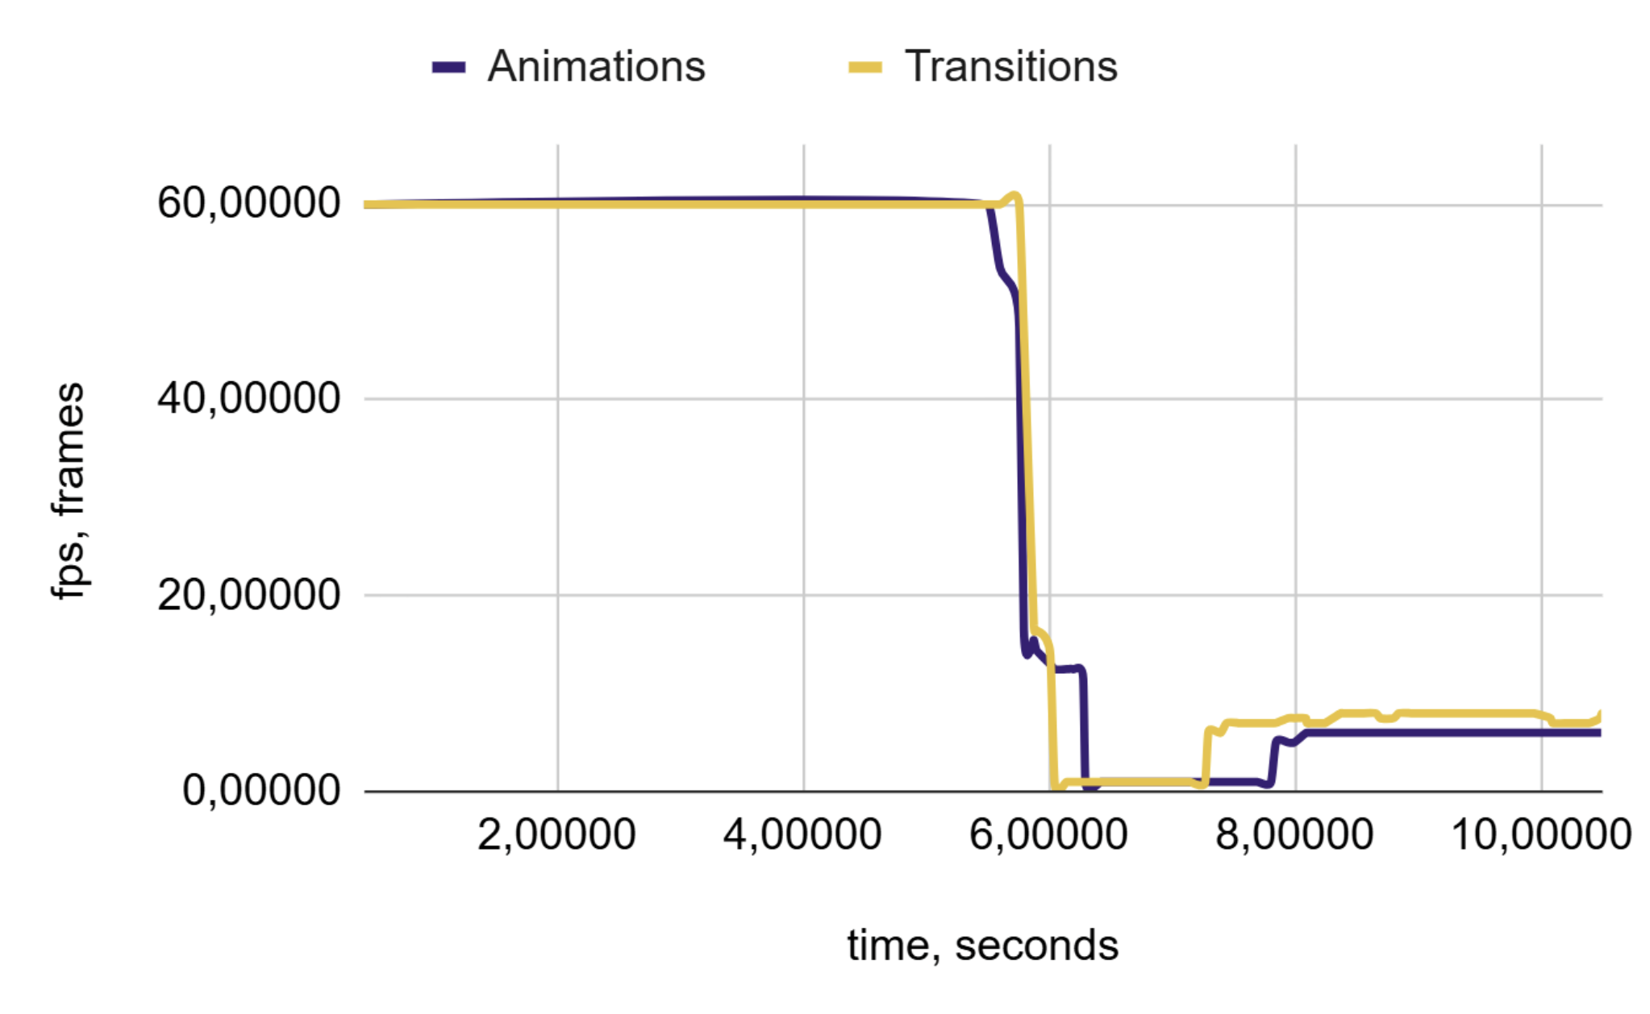
(a) | (b)
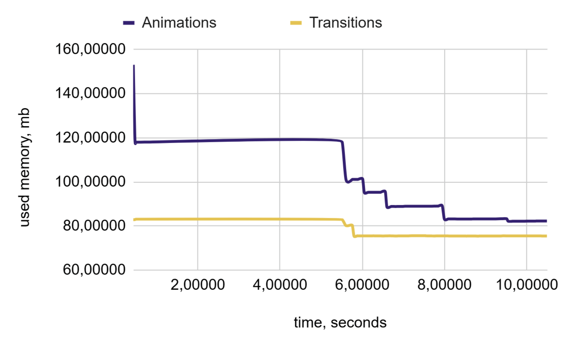
(c)
Figure 11. Performance Charts for 10,000 Blocks: (a) Frame Duration, (b) FPS, and (c) Memory Consumption
The percentage of memory consumption increased by 10.07%, indicating a higher utilization of memory compared with the transition periods. The number of FPS decreased by 43.24%, a change of 13.69%. This suggests that the FPS was lower than that during the transition phase. This situation reflects an increase in memory consumption and a decrease in FPS for animations. While memory consumption has increased, it is not as significant as in the previous instances.
During testing, we reduced the number of measurement points by 25%, owing to the large size of the dataset. However, this reduction allowed us to effectively compare the two methods. All the necessary data for conducting the comparative analysis were collected at this stage.

6.9. Testing the Null Hypothesis
Hypothesis testing provides a clear and statistically grounded understanding of how different CSS techniques, such as animations and transitions, affect system performance. Rather than relying on subjective impressions or isolated test results, this analysis quantifies whether the observed differences in performance metrics, such as delta FPS, average FPS, and memory consumption, are likely the result of actual performance effects or merely random variations. By evaluating this, we can confidently distinguish between insignificant fluctuations and genuine differences in performance. This enables us to identify which metrics are sensitive to the use of animations or transitions, and to determine the conditions under which performance impacts become statistically meaningful [25].
To assess whether the differences in performance metrics are statistically significant compared to the reference behaviour, we must evaluate the null hypothesis using previously collected data. A lower p-value indicates that the observed difference was less likely to be the result of random chance under the null hypothesis. The null hypothesis is defined in Equation (2).
$$t=\frac{\overline{X_{1}}-\overline{X_{2}}}{\sqrt{\frac{s_{1}^{2}}{n_{1}}-\frac{s_{2}^{2}}{n_{2}}}}$$ | (2)
Where:
- $\overline{X_{1}}, \overline{X_{2}}$ – sample means of groups 1 and 2.
- $s_{1}^{2}, s_{2}^{2}$ – sample variances of groups 1 and 2.
- $n_{1}, n_{2}$ – sample sizes of groups 1 and 2.

Table 1 summarizes the p-values for each test case across various sample sizes and key performance metrics such as Delta FPS, FPS, and memory consumption.
Table 1. Performance Comparison of CSS Animations vs Transitions
 | Delta | FPS | Memory
50 | 0.68719 | 0.2000 | 0.0000
250 | 0.31738 | 0.2303 | 0.0000
500 | 0.42836 | 0.44442 | 0.0359
1000 | 0.90298 | 0.74124 | 0.00018
2500 | 0.30050 | 0.30007 | 0.16354
5000 | 0.37203 | 0.82660 | 0.18461
7500 | 0.41617 | 0.37451 | 0.0000
10000 | 0.78432 | 0.24333 | 0.0000

The null hypothesis assumed that there was no difference between the groups for each metric. The p-values indicate the probability of observing the data if the null hypothesis is true. A p-value less than 0.05 suggests that the null hypothesis can be rejected, indicating a statistically significant difference.
The FPS and Delta sample sizes resulted in p-values above 0.05, indicating no statistically significant differences. This suggests that frame stability generally remains stable and is largely unaffected by the choice between animation and transition.
Memory consumption was significantly different between groups (p < 0.05). This indicates that memory consumption is the metric that is most consistently affected by the choice between CSS animations and transitions.

6.10. High Load Resistance Evaluation
To compare the two methods, we introduced a measure of the load resistance. The resistance column offers insight into the resistance of each method in relation to the optimal scenario, which uses 50 blocks. This metric was calculated by considering the weights [26] assigned to each aspect, as detailed in equation (3).
$$w_{delta}=0; w_{fps}=0.70; w_{memory}=0.30$$ | (3)
Where:
- $w_{fps}$ – weight assigned to the FPS, which was set at 0.70, indicating its greater significance compared to memory consumption.
- $w_{delta}$ – the weight assigned to memory consumption is set to 0.30, indicating that it is less critical than FPS.
- $w_{memory}$ – weight for the FPS delta calculation was set to zero, as it is more appropriate to evaluate the performance based on the actual FPS rather than its fluctuations.
The resistance metric is calculated according to Equation (4):
$$R_{i}=\frac{\sum_{j=delta}^{metrics}{ w_{j}× \left(\frac{m_{j}^{i}}{m_{j}^{50}}\right) }}{w}$$ | (4)
Where:
- $R_{i}$ = high load resistance for testing with $i$ data points.
- $metrics$ – set of evaluated metrics: delta, FPS, and memory.
- $i$ = number of data points used in test.
- $j$ – Current metric from set of metrics.
- $m_{j}^{i}$ is the average value of metric $j$ for the test with $i$ datapoints.
- $m_{j}^{50}$ is the average value of metric $j$ in the reference scenario, using 50 data points.
- $w_{j}$ is the weight assigned to metric $j$.
- $w$ is the total weight assigned to all metrics.
After receiving the initial values, they were normalized to the range of 0–1. The normalized resistance metric was calculated using Equation (5):
$$R_{i}^{n}=\frac{1}{R_{i}}$$ | (5)
Where:
- $R_{i}$ – high load resistance for the test with $i$ data points.
- $R_{i}^{n}$ – normalized value $R_{i}$ ranges from 0 to 1.
The lower the value, the lower the load resistance compared to the reference values. The performance characteristics for all test cases, along with their resistance to high loads, are summarized in Table 2.
The average stability was then calculated based on all values according to Equation (6):
$$R^{A/T}=\sum_{i=50}^{10,000}{\frac{R_{i}^{n}}{N}}$$ | (6)
Where:
- $N$ is the number of received resistance values.
- $A/T$ – indices for animations and transitions.
By substituting the initial values, we calculated the average resistance of 56.09% for animations and 55.96% for transitions. These results indicated that animations performed slightly better in terms of scaling. However, the differences were minimal, suggesting that both methods could be considered equivalent within an acceptable margin of error.
Table 2. Performance Comparison of CSS Animations vs Transitions
 | Animations |  |  |  | Transitions
 | Delta | FPS | Memory | Resistance | Delta | FPS | Memory | Resistance
50 | 16.69 | 60.00 | 18.39 | 100.00% | 16.69 | 60.00 | 18.27 | 100.00%
250 | 16.67 | 59.99 | 19.39 | 98.47% | 16.67 | 60.00 | 19.73 | 97.75%
500 | 16.68 | 59.97 | 22.08 | 94.55% | 16.67 | 59.98 | 21.96 | 94.52%
1000 | 16.74 | 59.82 | 25.61 | 89.75% | 16.74 | 59.85 | 25.25 | 90.02%
2500 | 33.68 | 31.43 | 37.33 | 51.45% | 35.84 | 29.98 | 36.86 | 49.85%
5000 | 81.65 | 14.34 | 55.28 | 25.99% | 84.96 | 1.20 | 56.50 | 25.64%
7500 | 142.43 | 10.38 | 92.40 | 17.98% | 172.28 | 9.25 | 79.35 | 17.02%
10000 | 221.51 | 7.66 | 85.24 | 14.45% | 200.88 | 9.13 | 75.70 | 17.02%

We frequently used the median in our calculations to eliminate potential outliers. The metrics analysed were combined memory consumption and FPS. The results represent the actual performance more accurately by adding weights for the memory consumption. When these weights were excluded from our metrics, animations exhibited a resistance of 54.98%, whereas the transitions exhibited a resistance of 55.01%. Although this adjustment alters the results, the difference remains minimal, reinforcing the idea that the rendering methods are equivalent.

6.11 Evaluating Memory Consumption Across Device Types
To objectively evaluate the results, it is crucial to consider the context of the target platform. The most widespread approach is to assess the memory consumption of both the mobile and desktop devices.
In modern desktop systems, the memory consumption of the browser is generally not a limiting factor. However, on older or resource-constrained devices, especially those equipped with 2–4 GB RAM, memory consumption can become a performance bottleneck. In our experiments, the average memory consumption was approximately 85.24 MB for animations and 75.70 MB for transitions, which is not likely to cause critical issues for most devices.
It should be emphasized that these figures were obtained in a clean testing environment without additional application logic or third-party libraries. In real-world applications, memory consumption typically ranges from 100 to 200 MB or more, depending on the complexity and features of the interface. In addition, not only does memory consumption affect system performance, it also affects device energy efficiency, as increased RAM usage leads to higher power consumption and thermal output, which are particularly relevant for mobile devices.

- CONCLUSION
In a comprehensive and large-scale experimental evaluation of the performance of CSS animations and transitions under various interface loads, ranging from 50 to 10,000 animated elements, was conducted. The objective was to quantitatively evaluate the behavior of each method in terms of the frame rate stability, memory consumption, and responsiveness at different levels of stress. For a single test using a single method, data were collected, yielding between 8,000 and 10,000 data points.
Low-load testing (50 – 2,500 elements) demonstrated similar performance in terms of the FPS and delta, with differences typically within a few percentage points that were not statistically significant. However, animations tended to use slightly more memory, even at minimal loads, and this trend became more pronounced as the number of elements increased. By the time there were 2,500 elements, a noticeable increase in both memory consumption and FPS for animations had begun to emerge.
Moderate-load testing (2,500–5,000 elements) demonstrated that animations have a higher FPS performance and lower memory consumption than transitions. This stage represents an optimal performance point under controlled conditions with stable metrics and no significant degradation.
High-load testing (7,500–10,000 elements) demonstrated that the memory consumption for animations increased significantly, up to 14% more than that for transitions. In addition, the FPS performance became more variable. At 7,500 elements, the FPS remained relatively high; however, at 10,000 elements, it decreased sharply, indicating a noticeable frame loss. Nonetheless, sufficient data were gathered to perform a reliable comparative analysis of both approaches under heavy loads.
To ensure an accurate comparison while considering the significance of various criteria, we conducted an assessment based on the weighted metrics. The weights were assigned to memory and FPS, with a higher weight assigned to the FPS metric because it is deemed more indicative than memory consumption. The results showed that by using these weights, the animation method was 0.13% more effective. Significantly, the memory consumption metric was assigned smaller weights, which is why it was considered less significant than FPS. However, when evaluated using the equivalent criteria method, the transition method proved to be 0.03% more advantageous than the animation method. In the memory consumption test, animations used 120 MB of memory, whereas transitions used 80 MB. Although the difference in memory consumption is notable, it is not critical, as the increased FPS for rendering compensates for higher memory consumption.
Null hypothesis testing confirmed that the delta (frame stability) and FPS remained largely unaffected by the choice between CSS animations and transitions across all tested loads. However, significant differences were observed in memory consumption at multiple load levels. These findings demonstrate that memory consumption is the most sensitive metric to the animation method used, providing valuable insights for making informed decisions based on performance priorities.
Transitions generally use memory more efficiently than animations, which is understandable, given their rendering methods. However, both approaches demonstrate similar levels of overall memory consumption. Animation memory consumption tends to be higher than that of the transitions for a larger number of elements. However, for memory consumption to become a significant concern, an application must contain substantial functionality and animated content.
From a practical standpoint, this means that while one method may have a slight advantage over the other, both approaches are acceptable for use. It is important to recognize that animations can consume memory during implementation; however, as demonstrated in the 50-element dataset, this difference in memory consumption is generally insignificant compared to transitions.

ACKNOWLEDGEMENT
The authors would like to thank the anonymous reviewers for their valuable comments.

FUNDING STATEMENT
The authors received no funding from any party for the research and publication of this article.

AUTHOR CONTRIBUTIONS
Dmitrii Zakharov: Conceptualization, Data Curation, Methodology, Validation, Writing – Original Draft Preparation;
Ekaterina Mironenko: Reviewing, Proofreading.

CONFLICT OF INTERESTS
No conflict of interests were disclosed.

ETHICS STATEMENTS
Our publication ethics follow The Committee of Publication Ethics (COPE) guideline. https://publicationethics.org/

DATA AVAILABILITY
The data that support the findings of this study are available from the corresponding author upon reasonable request.

REFERENCES
[1] StatCounter, “StatCounter Global Stats - Browser, OS, Search Engine Including Mobile Usage Share,” StatCounter, [Online]. Available: https://gs.statcounter.com. [Accessed: 3-Jul-2025].
[2] H.K. Lam, and W.B. Lee, “User behavior modeling and analysis for online information retrieval,” IEEE Trans. Knowl. Data Eng., vol. 24, no. 4, pp. 732–744, Apr. 2012.
[3] T. Osmani, “The psychology of web performance – time is money,” in Time Is Money: The Business Value of Web Performance. Sebastopol, CA, USA: O’Reilly Media, 2015. [Online]. Available: https://www.oreilly.com/library/view/time-is-money/9781491928783/ch01.html. [Accessed: 8-Jul-2025].
[4] Google Developers, “RenderingNG architecture,” Chrome for Developers, [Online]. Available: https://developer.chrome.com/docs/chromium/renderingng-architecture?hl=ru. [Accessed: 8-Jul-2025].
[5] V. Thakar, R. Thakar, and P. Vyas, “Investigation on understanding the numeracy capacity of intellectually disabled students using enabling technology tools: Web application, AR and UI/UX,” Journal of Informatics and Web Engineering, vol. 3, no. 3, pp. 176–189, 2024, doi: 10.33093/jiwe.2024.3.3.11.
[6] Mozilla Contributors, “CSS animations,” MDN Web Docs, [Online]. Available: https://developer.mozilla.org/en-US/docs/Web/CSS/CSS_animations. [Accessed: 3-Jul-2025].
[7] The Chromium Authors, “Chromium Docs – How cc works,” Chromium source documentation, May 27, 2025. [Online]. Available: https://chromium.googlesource.com/chromium/src/+/lkgr/docs/how_cc_works.md#Compositor-frames_render-passes_quads. [Accessed: 8-Jul-2025].
[8] Google Developers, “Rendering performance,” web.dev, [Online]. Available: https://web.dev/articles/rendering-performance?hl=ru. [Accessed: 8-Jul-2025].
[9] Mozilla Contributors, “animationend - Web APIs | MDN,” Mozilla Developer Network, 2025. [Online]. Available: https://developer.mozilla.org/en-US/docs/Web/API/Element/animationend_event. [Accessed: 8-Jul-2025].
[10] Mozilla Contributors, “transitionend - Web APIs | MDN,” Mozilla Developer Network, 2025. [Online]. Available: https://developer.mozilla.org/en-US/docs/Web/API/Element/transitionend_event. [Accessed: 8-Jul-2025].
[11] World Wide Web Consortium (W3C), “Cascading Style Sheets (CSS) 3,” 2025. [Online]. Available: https://www.w3.org/Style/CSS/. [Accessed: 9-Jul-2025].
[12] M. Beňo, and M. Ölvecký, “Measuring the performance of techniques for dynamic 2D animation in web browsers,” J. Appl. Math., Stat. Inf., vol. 20, no. 2, pp. 80–81, 2024.
[13] J. Masner, P. Šimek, J. Jarolímek, V. Očenášek, and J. Pavlík, “Analysis of CSS organization styles and expensive properties in regard to rendering performance,” in Proc. Agrarian Perspectives XXIX: Trends and Challenges of Agrarian Sector, 29th Int. Sci. Conf., Prague, Czech Republic, Sep. 16–17, 2020, pp. 215–220.
[14] Siteefy, “How many websites are there in the world? (2024),” Siteefy, [Online]. Available: https://siteefy.com/how-many-websites-are-there. [Accessed: 9-Jul-2025].
[15] R. Bhutia, S.A.K. Dave, I.R. Mallela, R. Mall, A. Das, and A. Joshi, “Optimizing web interfaces with AI-generated CSS through machine learning and deep learning,” in Proc. 2024 13th Int. Conf. Syst. Modeling Adv. Res. Trends (SMART), Moradabad, India, Dec. 2024, doi: 10.1109/SMART63812.2024.10882500.
[16] V.P.K. Vemuri, “Addressing critical challenges in front-end performance and scalability,” Int. J. Multidiscip. Res. Growth Eval., vol. 1, no. 5, pp. 156–161, Nov.–Dec. 2020, doi: 10.54660/IJMRGE.2020.1.5.156-161.
[17] Y. Yang, “Web front-end application performance improvement method based on component-based architecture,” Int. J. Eng. Adv., vol. 2, no. 2, pp. 24–30, 2025, doi: 10.71222/sg9eef87.
[18] A.S. Shethiya, “Scalability and performance optimization in web application development,” Integrated Journal of Science and Technology, 2(1).
[19] M. Daniel, J. Honoroff, and C. Miller, “Engineering heap overflow exploits with JavaScript,” in Proc. 2nd USENIX Workshop Offensive Technol. (WOOT '08), 8(1-6), pp.11, 2008.
[20] Mozilla Contributors, “window.requestAnimationFrame() - Web APIs | MDN,” Mozilla Developer Network, 2023. [Online]. Available: https://developer.mozilla.org/en-US/docs/Web/API/window/requestAnimationFrame. [Accessed: 10-Jul-2025].
[21] MDN Web Docs, “Performance: now() method - Web APIs | MDN,” Mozilla, 2025. [Online]. Available: https://developer.mozilla.org/en-US/docs/Web/API/Performance/now. [Accessed: 12-Jul-2025].
[22] Mozilla Contributors, “SPA - Glossary - MDN Web Docs,” Mozilla Developer Network, 2023. [Online]. Available: https://developer.mozilla.org/en-US/docs/Glossary/SPA. [Accessed: 13-Jul-2025].
[23] Pinia, “Introduction,” Pinia - Vue Store, [Online]. Available: https://pinia.vuejs.org/introduction.html. [Accessed: 9-Jul-2025].
[24] VueUse, “Guide,” VueUse Documentation, [Online]. Available: https://vueuse.org/guide. [Accessed: 12-Jul-2025].
[25] A. A. Zaveri, R. Mashood, N. Faisal, M. Parveen, N. Sami, M. Nazar, and S. Imtiaz, “MobiTest – A software for mobile-based testing,” Journal of Informatics and Web Engineering, vol. 3, no. 3, Art. 1, 2024, doi: 10.33093/jiwe.2024.3.3.1.
[26] R.L. Keeney, and H. Raiffa, “Decisions with Multiple Objectives: Preferences and Value Trade-Offs”, Cambridge, U.K.: Cambridge Univ. Press, 1993.

BIOGRAPHIES OF AUTHORS
 | Dmitrii Zakharov is a Staff Engineer in the sports betting industry with over nine years of experience in technology, including four years in engineering leadership. He specializes in frontend engineering, performance optimization, and scalable UI architectures. His expertise includes Vue.js, Nuxt.js, React.js, TypeScript, Node.js, and GraphQL, along with DevOps and CI/CD practices. He holds an M.Eng. in Information Technology from Sevastopol State Technical University, Russia. He can be contacted at email: forsocials.mail@gmail.com.
 | Ekaterina Mironenko is a Quality Assurance Engineer with a background in linguistics and education. Before entering the tech industry, she worked as an English teacher, developing strong communication and analytical skills. Her expertise includes software testing, documentation, and quality assurance processes. She holds an M.A. in Philology from Sevastopol State Technical University, Russia. She can be contacted at email: formycars.mail@gmail.com.

